# UNIT-IV

**MEMORY AND INPUT/OUTPUT ORGANIZATION**

## Memory Organization: Memory Hierarchy Main Memory Auxiliary Memory Associative Memory Cache Memory Virtual Memory.



**Input/output Organization: Input-Output Interface Asynchronous Data Transfer Modes of Transfer**



**Priority Interrupt**



**Direct Memory Access (DMA).**



**MEMORY HIERARCHY**

* The memory unit is an essential component in any digital computer since it is needed for storing programs and data. A very small computer with a limited application may be able to fulfill its intended task without the need of additional storage capacity.
* The memory unit that communicates directly with the CPU is called the **main memory**. Devices that provide backup storage are called **auxiliary memory**. The most common auxiliary memory devices used in computer systems are magnetic disks and tapes. They are used for storing system programs, large data files, and other backup information. Only programs and data currently needed by the processor reside in main memory. All other information is stored in auxiliary memory and transferred to main memory when needed.
* The memory hierarchy system consists of all storage devices employed in a computer system from the slow but high-capacity auxiliary memory to a relatively faster main memory, to an even smaller and faster cache memory accessible to the high-speed processing logic.

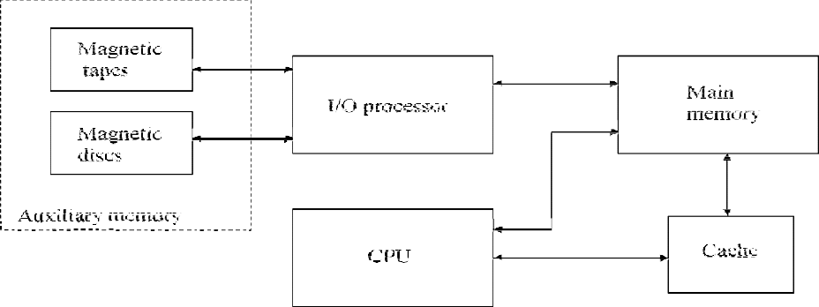

Memory hierarchy in computer system

* The main memory occupies a central position by being able to communicate directly with the CPU and with auxiliary memory devices through an I/O processor.
* When programs not residing in main memory are needed by the CPU, they are brought in from auxiliary memory. Programs not currently needed in main memory are transferred into auxiliary memory to provide space for currently used programs and data.
* A special very-high speed memory called a **cache** is sometimes used to increase the speed of processing by making current programs and data available to the CPU at a rapid rate. The cache memory is employed in computer systems to compensate for the speed differential between main memory access time and processor logic.
* The overall goal of using a memory hierarchy is to obtain the highest-possible average access speed while minimizing the total cost of the entire memory system.
* Auxiliary and cache memories are used for different purposes. The cache holds those parts of the program and data that are most heavily used, while the auxiliary memory holds those parts that are not presently used by the CPU. Moreover, the CPU has direct access to both cache and main memory but not to auxiliary memory. The transfer from auxiliary to main memory is usually done by means of direct memory access of large blocks of data. The typical access time ratio between cache and main memory is about 1 to 7. For example, a typical cache memory may have an access time of 100ns, while main memory access time may be 700ns. Auxiliary memory average access time is usually 1000 times that of main memory. Block size in auxiliary memory typically ranges from256 to 2048 words, while cache block size is typically from 1 to 16 words.
* Many operating systems are designed to enable the CPU to process a number of independent programs concurrently. This concept, called **multiprogramming**, refers to the existence of two or more programs in different parts of the memory hierarchy at the same time.
* In a multiprogramming system, when one program is waiting for input or output transfer, there is another program ready to utilize the CPU.

# MAIN MEMORY

* The main memory is the central storage unit in a computer system. It is a relatively large and fast memory used to store programs and data during the computer operation.
* The principal technology used for the main memory is based on semiconductor integrated circuits.
* Integrated circuit RAM chips are available in two possible operating modes, **static** and **dynamic.** The static RAM consists essentially of internal flip-flops that store the binary information. The stored information remains valid as long as power is applied to unit. The dynamic RAM stores the binary information in the form of electric charges that are applied to capacitors. The capacitors are provided inside the chip by MOS transistors. The stored charge on the capacitors tends to discharge with time and the capacitors must be periodically recharged by refreshing the dynamic memory.
* The dynamic RAM offers reduced power consumption and larger storage capacity in a single memory chip.
* The static RAM is easier to use and has shorted read and write cycles.
* RAM refers to a random-access memory, but it is used to designate a read/write memory to distinguish it from a read-only memory, although ROM is also random access.
* RAM is used for storing the bulk of the programs and data that are subject to change. ROM is used for storing programs that are permanently resident in the computer
* The ROM portion of main memory is needed for storing an initial program called a **bootstrap loader**. The bootstrap loader is a program whose function is to start the computer software operating when power is turned on.
* Since RAM is volatile, its contents are destroyed when power is turned off. The contents of ROM remain unchanged after power is turned off and on again.
* The startup of a computer consists of turning the power on and starting the execution of an initial program. Thus when power is turned on, the hardware of the computer sets the program counter to the first address of the bootstrap loader. The bootstrap program loads a portion of the operating system from disk to main memory and control is then transferred to the operating system, which prepares the computer for general use.
* RAM and ROM chips are available in a variety of sizes. If the memory needed for the computer is larger than the capacity of one chip, it is necessary to combine a number of chips to form the required memory size. Ex: 1024 × 8 memory can be constructed with 128 × 8 RAM chips and 512 × 8 ROM chips.

## RAM AND ROM CHIPS

* A RAM chip is better suited for communication with the CPU if it has one or more control inputs that select the chip only when needed. Another common feature is a bidirectional data bus that allows the transfer of data either from memory to CPU during a read operation or from CPU to memory during a write operation.
* A bidirectional bus can be constructed with three-state buffers.
* The block diagram of a RAM chip is shown in Fig.

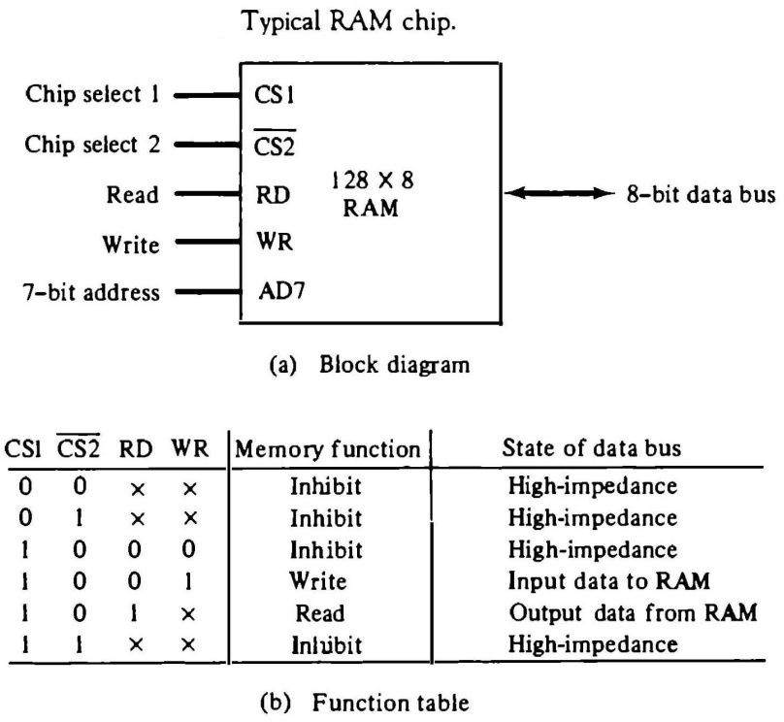

* The capacity of the memory is 128 words of eight bits (one byte) per word. This requires a 7-bit address and an 8-bit bidirectional data bus. The read and write inputs specify the memory operation and the two chips select (CS) control inputs are for enabling the chip only when it is selected by the microprocessor. The availability of more than one control input to select the chip facilitates the decoding of the address lines when multiple chips are used in the microcomputer.
* The read and write inputs are sometimes combined into one line labeled R/W. When the chip is selected, the two binary states in this line specify the two operations or read or write.
* The unit is in operation only when CS1 = 1 and CS2 = 0.
* If the chip select inputs are not enabled, or if they are enabled but the read but the read or write inputs are not enabled, the memory is inhibited and its data bus is in a high-impedance state.
* When CS1 = 1 and CS2 = 0, the memory can be placed in a write or read mode. When the WR input is enabled, the memory stores a byte from the data bus into a location specified by the address input lines.
* When the RD input is enabled, the content of the selected byte is placed into the data bus. The RD and WR signals control the memory operation as well as the bus buffers associated with the bidirectional data bus.
* A ROM chip is organized externally in a similar manner. ROM can only read, the data bus can only be in an output mode. The block diagram of a ROM chip is shown in Fig.

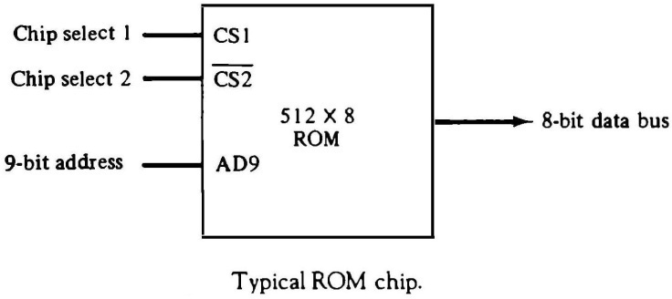

* The nine address lines in the ROM chip specify any one of the 512 bytes stored in it. The two chip select inputs must be CS1 = 1 and CS2 = 0 for the unit to operate. Otherwise, the data bus is in a high-impedance state. There is no need for a read or write control because the unit can only read. Thus when the chip is enabled by the two select inputs, the byte selected by the address lines appears on the data bus.

## MEMORY ADDRESS MAP

* The designer of a computer system must calculate the amount of memory required for the particular application and assign it to either RAM or ROM. The interconnection between memory and processor is then established form knowledge of the size of memory needed and the type of RAM and ROM chips available.
* A memory address map, is a pictorial representation of assigned address space for each chip in the system.
* To demonstrate with a particular example, assume that a computer system needs 512 bytes of RAM and 512 bytes of ROM.
* The memory address map for this configuration is shown in Table.

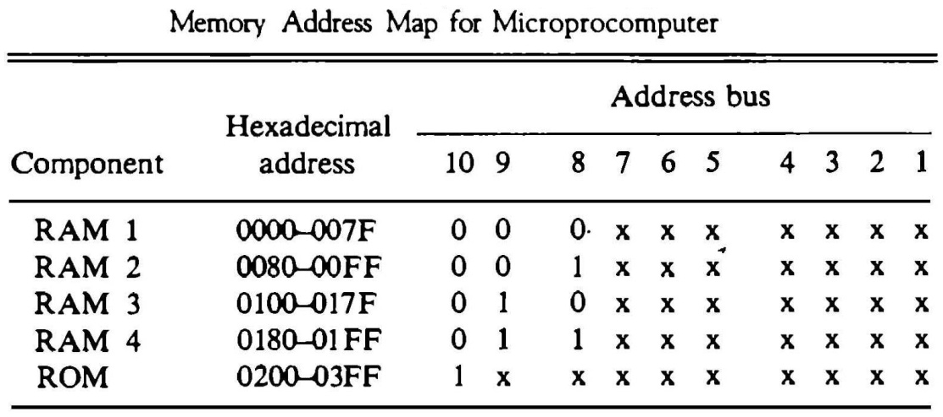

* The small x’s under the address bus lines designate those lines that must be connected to the address inputs in each chip.
* The RAM chips have 128 bytes and need seven address lines. The ROM chip has 512 bytes and needs 9 address lines.
* It is now necessary to distinguish between four RAM chips by assigning to each a different address. For this particular example we choose bus lines 8 and 9 to represent four distinct binary combinations.
* The distinction between a RAM and ROM address is done with another bus line. Here we choose line 10 for this purpose. When line 10 is 0, the CPU selects a RAM, and when this line is equal to 1, it selects the ROM.
* The first hexadecimal digit represents lines 13 to 16 and is always 0. The next hexadecimal digit represents lines 9 to 12, but lines 11 and 12 are always 0. The range of hexadecimal addresses for each component is determined from the x’s associated with it. These x’s represent a binary number that can range from an all-0’s to an all-1’s value.

## MEMORY CONNECTION TO CPU

* RAM and ROM chips are connected to a CPU through the data and address buses.
* The low-order lines in the address bus select the byte within the chips and other lines in the address bus select a particular chip through its chip select inputs.
* The connection of memory chips to the CPU is shown in Fig. This configuration gives a memory capacity of 512 bytes of RAM and 512 bytes of ROM.
* Each RAM receives the seven low-order bits of the address bus to select one of 128 possible bytes. The particular RAM chip selected is determined from lines 8 and 9 in the address bus. This is done through a 2 × 4 decoder whose outputs go to the CS1 input in each RAM chip. Thus, when address lines 8 and 9 are equal to 00, the first RAM chip is selected. When 01, the second RAM chip is selected, and so on.
* The RD and WR outputs from the microprocessor are applied to the inputs of each RAM chip.
* The selection between RAM and ROM is achieved through bus line 10. The RAMs are selected when the bit in this line is 0, and the ROM when the bit is 1. The other chip select input in the ROM is connected to the RD control line for the ROM chip to be enabled only during a read operation.
* Address bus lines 1 to 9 are applied to the input address of ROM without going through the decoder. This assigns addresses 0 to 511 to RAM and 512 to 1023 to ROM.
* The data bus of the ROM has only an output capability, whereas the data bus connected to the RAMs can transfer information in both directions.

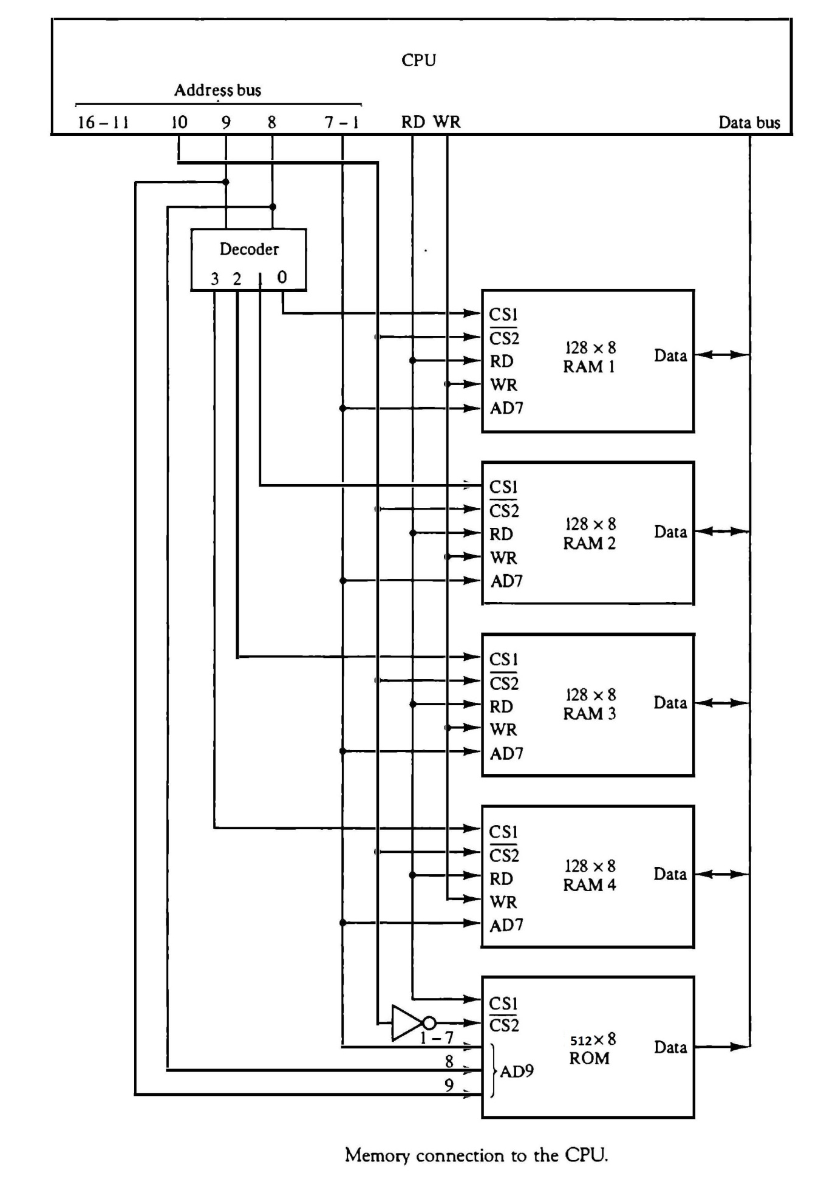

# AUXILIARY MEMORY:

* The most common auxiliary memory devices used in computer systems are magnetic disks and magnetic tapes. Other components used, but not as frequently, are magnetic drums, magnetic bubble memory, and optical disks.
* The important characteristics of any device are its access mode, access time, transfer rate, capacity, and cost.
* Auxiliary storage is organized in records or blocks. A record is a specified number of characters or words. Reading or writing is always done on entire records. The transfer rate is the number of characters or words that the device can transfer per second, after it has been positioned at the beginning of the record.

## MAGNETIC DISKS

* A magnetic disk is a circular plate constructed of metal or plastic coated with magnetized material. Often both sides of the disk are used and several disks may be stacked on one spindle with read/write heads available on each surface.
* All disks rotate together at high speed and are not stopped or started from access purposes.
* Bits are stored in the magnetized surface in spots along concentric circles called tracks. The tracks are commonly divided into sections called sectors. In most systems, the minimum quantity of information which can be transferred is a sector.
* 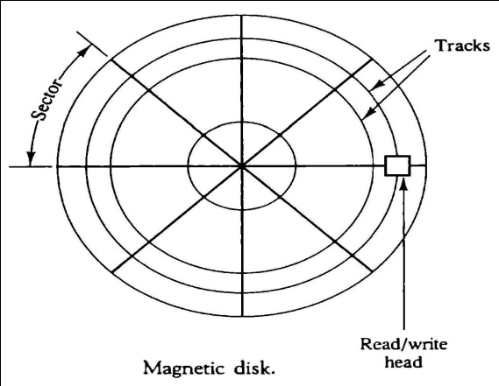Some units use a single read/write head from each disk surface. The track address bits are used by a mechanical assembly to move the head into the specified track position before reading or writing.
* In other disk systems, separate read/write heads are provided for each track in each surface. The address can then select a particular track electronically through a decoder circuit. This type of unit is more expensive and is found only in very large computer systems.
* A disk system is addressed by address bits that specify the disk number, the disk surface, the sector number and the track within the sector.
* After the read/write heads are positioned in the specified track, the system has to wait until the rotating disk reaches the specified sector under the read/write head.
* Information transfer is very fast once the beginning of a sector has been reached.
* Disks may have multiple heads and simultaneous transfer of bits from several tracks at the same time.
* Disks that are permanently attached to the unit assembly and cannot be removed by the occasional user are called hard disks. A disk drive with removable disks is called a floppy disk.
* The disks used with a floppy disk drive are small removable disks made of plastic coated with magnetic recording material. There are two sizes commonly used, with diameters of 5.25 and

3.5 inches. The 3.5-inch disks are smaller and can store more data than can the 5.25-inch disks.

## MAGNETIC TAPE

* The Magnetic tape itself is a strip of plastic coated with a magnetic recording medium. Bits are recorded as magnetic spots on the tape along several tracks. Usually, seven or nine bits are recorded simultaneously to form a character together with a parity bit.
* Read/write heads are mounted one in each track so that data can be recorded and read as a sequence of characters.
* Magnetic tape units can be stopped, started to move forward or in reverse, or can be rewound.
* Gaps of unrecorded tape are inserted between records where the tape can be stopped. The tape starts moving while in a gap and attains its constant speed by the time it reaches the next record.
* Each record on tape has an identification bit pattern at the beginning and end. By reading the bit pattern at the beginning, the tape control identifies the record number. By reading the bit pattern at the end of the record, the control recognizes the beginning of a gap. A tape unit is addressed by specifying the record number of characters in the record. Records may be of fixed or variable length.

# ASSOCIATIVE MEMORY

* The number of accesses to memory depends on the location of the item and the efficiency of the search algorithm. Many search algorithms have been developed to minimize the number of accesses while searching for an item in a random or sequential access memory.
* The time required to find an item stored in memory can be reduced considerably if stored data can be identified for access by the content of the data itself rather than by an address.
* A memory unit accessed by content is called an ***associative memory or content addressable memory (CAM).***
* When a word is to be read from an associative memory, the content of the word, or part of the word, is specified. The memory locates all words which match the specified content and marks them for reading.
* An associative memory is more expensive than a random access memory because each cell must have storage capability as well as logic circuits for matching its content with an external argument. For this reason, associative memories are used in applications where the search time is very critical and must be very short.

## HARDWARE ORGANIZATION

* The block diagram of an associative memory is shown in Fig.
* It consists of a memory array and logic for *m* words with *n* bits per word. The argument register A and key register K each have n bits, one for each bit of a word. The match register M has m bits, one for each memory word.
* Each word in memory is compared in parallel with the content of the argument register. The words that match the bits of the argument register set a corresponding bit in the match register.
* After the matching process, those bits in the match register that have been set indicate the fact that their corresponding words have been matched.
* Reading is accomplished by a sequential access to memory for those words whose corresponding bits in the match register have been set.
* The key register provides a mask for choosing a particular field or key in the argument word. The entire argument is compared with each memory word if the key register contains all 1’s. Otherwise, only those bits in the argument that have 1’s in their corresponding position of the key register are compared.
* To illustrate with a numerical example, suppose that the argument register A and the key register K have the bit configuration shown below. Only the three leftmost bits of A are compared with memory words because K has 1’s in these positions.

A 101 111100

K 111 000000

Word 1 100 111100 no match

Word 2 101 000001 match

* 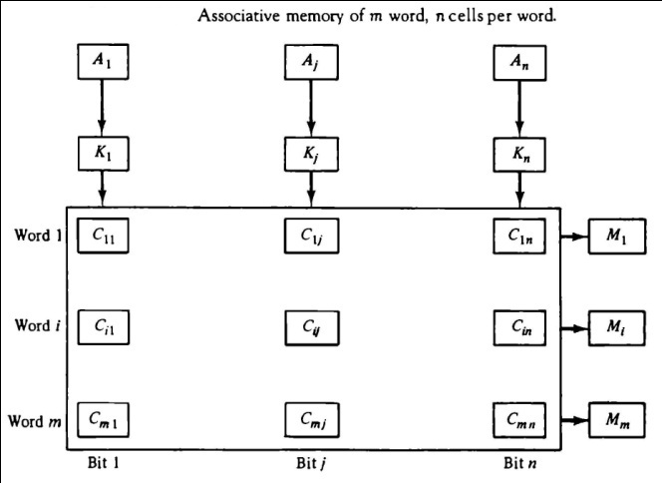The relation between the memory array and external registers in an associative memory is shown in Fig.
* The cells in the array are marked by the letter C with two subscripts. The first subscript gives the word number and the second specifies the bit position in the word. Thus cell Cij is the cell for bit j in word i.
* A bit Aj in the argument register is compared with all the bits in column j of the array provided that Kj

= 1. This is done for all columns j = 1, 2,…,n.

* If a match occurs between all the unmasked bits of the argument and the bits in word i, the corresponding bit Mi in the match register is set to 1. If one or more unmasked bits of the argument and the word do not match, Mi is cleared to 0
* The internal organization of a typical cell Cij is shown in Fig.
* 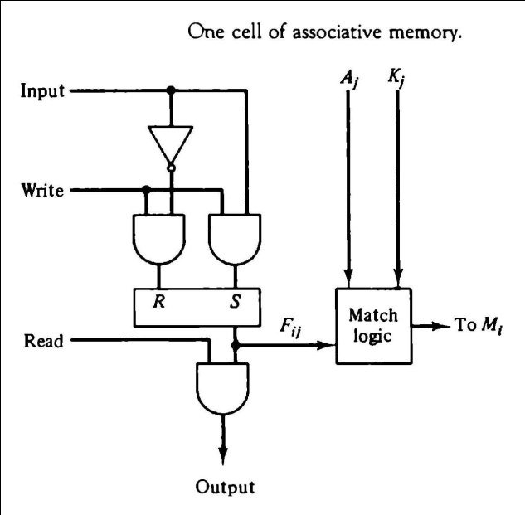 It consists of a flipflop storage element Fij and the circuits for reading, writing, and matching the cell.
* The input bit is transferred into the storage cell during a write operation. The bit stored is read out during a read operation.
* The match logic compares the content of the storage cell with the corresponding unmasked bit of the argument and provides an output for the decision logic that sets the bit in Mi.

## MATCH LOGIC

* The match logic for each word can be derived from the comparison algorithm for two binary numbers. First, we neglect the key bits and compare the argument in A with the bits stored in the cells of the words. Word i is equal to the argument in A if Aj = Fij for j = 1, 2,…, n. Two bits are equal if they are both 1 or both 0. The equality of two bits can be expressed logically by the Boolean function

## xj= Aj Fij + A'jF'ij

where xj = 1 if the pair of bits in position j are equal; otherwise, xj = 0.

* For a word i to be equal to the argument in A we must have all xj variables equal to 1.
* This is the condition for setting the corresponding match bit Mi to 1. The Boolean function for this condition is

## Mi= x1 x2 x3 … xn

* Include the key bit Kj in the comparison logic. The requirement is that if Kj = 0,the corresponding bits of Aj and Fij need no comparison. Only when Kj = 1 must they be compared. This requirement is achieved by ORing each term with K’j , thus:

xj + K’j = xj if Kj=1

1 if Kj=0

* When Kj = 1, we have Kj’ = 0 and xj + 0 = xj. When Kj = 0, then Kj’ = 1 xj + 1 = 1. A term (xj +Kj’) will be in the 1 state if its pair of bitsis not compared. This is necessary because each term is ANDed with all other terms so that an output of 1 will have no effect. The comparison of the bits has an effect only when Kj = 1.
* The match logic for word i in an associative memory can now be expressed by the following Boolean function:

## Mi = (x1 + K '1) (x2 + K '2 ) (x3 + K '3 ) …. (xn + K 'n)

* Each term in the expression will be equal to 1 if its corresponding Kj = 0. If Kj = 1, the term will be either 0 or 1 depending on the value of xj. A match will occur and Mi will be equal to 1 if all terms are equal to 1.
* If we substitute the original definition of xj. the Boolean function above can be expressed as follows:

**Mi =** ∏n (Aj Fij + AujFuij + K**′**j)

j=1

* The circuit for matching one word is shown in Fig. Each cell requires two AND gates and one OR gate. The inverters for Aj and Kj are needed once for each column and are used for all bits in the column. The output of all OR gates in the cells of the same word go to the input of a common AND gate to generate the match signal for Mi. Mi will be logic 1 if a match occurs and 0 if no match occurs. Note that if the key register contains all 0’s, output Mi will be a 1

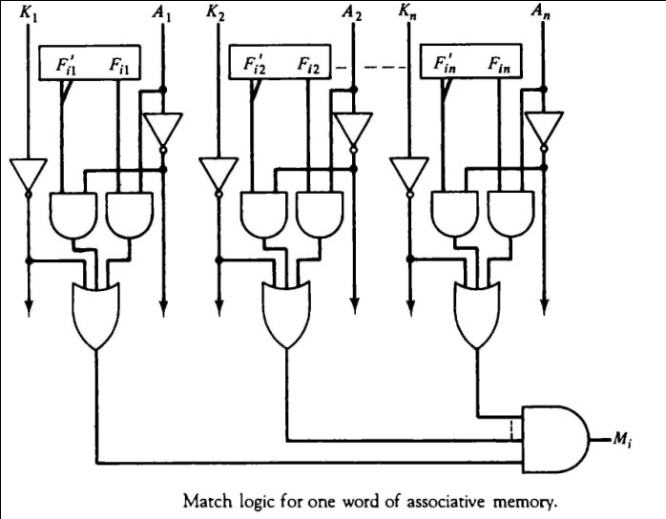 *14*

irrespective of the value of A or the word. This occurrence must be avoided during normal operation.

## READ OPERATION

* If more than one word in memory matches the unmasked argument field, all the matched words will have 1’s in the corresponding bit position of

the match register. It is then necessary to scan the bits of the match register one at a time. The matched words are read in sequence by applying a read signal to each word line whose corresponding Mi bit is a 1.

* In most applications, the associative memory stores a table with no two identical items under a given key. In this case, only one word may match the unmasked argument field. By connecting output Mi directly to the read line in the same word position (instead of the M register), the content of the matched word will be presented automatically at the output lines and no specialread command signal is needed.

## WRITE OPERATION

* An associative memory must have a write capability for storing the information to be searched.
* Writing in an associative memory can take different forms, depending on the application. If the entire memory is loaded with new information at once prior to a search operation then the writing can be done by addressing each location in sequence. This will make the device a random-access memory for writing and a content addressable memory for reading. The advantage here is that the address for input can be decoded as in a random-access memory. Thus instead of having m address lines, one for each word in memory, the number of address lines can be reduced by the decoder to d lines, where m = 2d.
* If unwanted words have to be deleted and new words inserted one at a time, there is a need for a special register to distinguish between active and inactive words. This register, sometimes called a *tag register*.
* For every active word stored in memory, the corresponding bit in the tag register is set to 1. A word is deleted from memory by clearing its tag bit to 0.
* Words are stored in memory by scanning the tag register until the first 0 bit is encountered. This gives the first available inactive word and a position for writing a new word. After the new word is stored in memory it is made active by setting its tag bit to 1. An unwanted word when deleted from memory can be cleared to all 0’s if this value is used to specify an empty location.

## CACHE MEMORY

* Locality of Reference: The references to memory at any given time interval tends to be confined within a localized area.
* When a program loop is executed, the CPU repeatedly refers to the set of instructions in memory that constitute the loop.
* Every time a given subroutine is called, its set of instructions is fetched from memory. Thus loops and subroutines tend to localize the references to memory for fetching instructions.
* Iterative procedures refer to common memory locations and array of numbers are confined within a local portion of memory
* If the active portions of the program and data are placed in a fast small memory, the average memory access time can be reduced, thus reducing the total execution time of the program. Such a fast small memory is referred to as a cache memory. The cache is the fastest component in the memory hierarchy and approaches the speed of CPU components.
* When the CPU needs to access memory, the cache is examined. If the word is found in the cache, it is read from the fast memory. If the word addressed by the CPU is not found in the cache, the main memory is accessed to read the word. A block of words containing the one just accessed is then transferred from main memory to cache memory
* The performance of cache memory is frequently measured in terms of a quantity called **hit ratio**. When the CPU refers to memory and finds the word in cache, it is said to produce a hit. If the word is not found in cache, it is in main memory and it counts as a miss. *The ratio of the number of hits divided by the total CPU references to memory (hits plus misses) is the hit ratio.*
* The average memory access time of a computer system can be improved considerably by use of a cache*.*
* The transformation of data from main memory to cache memory is referred to as a mapping process. Three types of mapping procedures are :

1. Associative mapping
2. Direct mapping
3. Set-associative mapping.

* Consider the following memory organization:

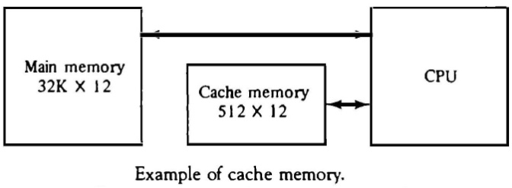

## ASSOCIATIVE MAPPING

* 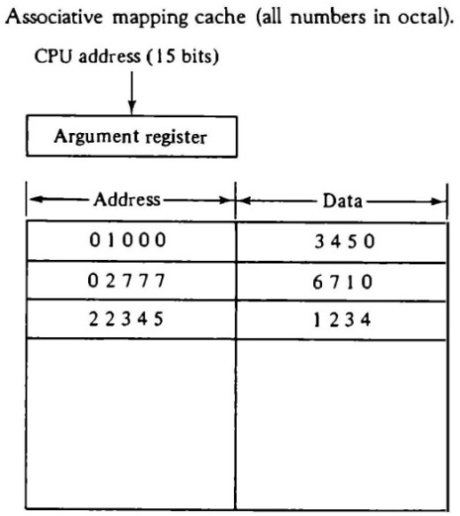The faster and most flexible cache organization use an associative memory. The associative memory stores both the address and content (data) of the memory word. This permits any location in cache to store any word from main memory.
* A CPU address of 15 bits is placed in the argument register and the associative memory is searched for a matching address. If the address is found, the corresponding 12-bit data is read and sent to the CPU.
* If no match occurs, the main memory is accessed for the word. The address-data pair is then transferred to the associative cache memory. If the cache is full, an address−data pair must be displaced to make room for a pair that is needed and not presently in the cache.
* The decision as to what pair is replaced is determined from the replacement algorithm that the designer chooses for the cache. A simple procedure is to replace cells of the cache in round- robin order whenever a new word is requested from main memory. This constitutes a first-in first-out (FIFO) replacement policy.

## DIRECT MAPPING

* 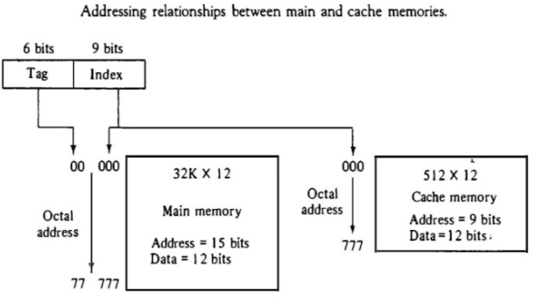Associative memories are expensive compared to random-access memories because of the added logic associated with each cell.
* Direct mapping uses RAM instead of CAM.
* 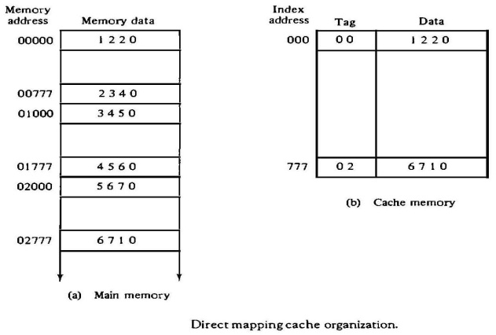The n-bit memory address is divided into two fields: k bits for the index field and n-k bits for the tag field. The direct mapping cache organization uses the n-bit address to access the main memory and the k-bit index to access the cache.
* The internal organization of the words in the cache memory is as shown in Fig
* Each word in cache consists of the data word and its associated tag. When a new word is first brought into the cache, the tag bits are stored alongside the data bits. When the CPU generates a memory request, the index field is used for the address to access the cache.
* The tag field of the CPU address is compared with the tag in the word read from the cache. If the two tags match, there is a hit and the desired data word is in cache. If there is no match, there is a miss and the required word is read from main memory. It is then stored in the cache together with the new tag, replacing the previous value.
* The disadvantage of direct mapping is that the hit ratio can drop considerably if two or more words whose addresses have the same index but different tags are accessed repeatedly.
* Suppose that the CPU now wants to access the word at address 02000. The index address is 000, so it is sued to access the cache. The two tags are then compared. The cache tag is 00 but the address tag is 02, which does not produce a match. Therefore, the main memory is accessed and the data word 5670 is transferred to the CPU. The cache word at index address 000 is then replaced with a tag of 02 and data of 5670.
* 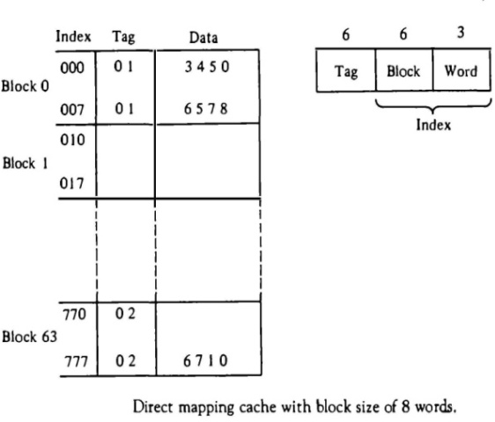The direct-mapping uses a block size of one word. The same organization but using a block size of 8 words is shown in Fig.
* The index field is now divided into two parts: the block field and the word field. The tag field stored within the cache is common to all eight words of the same block.
* Every time a miss occurs, an entire block of eight words must be transferred from main memory to cache memory. Although this takes extra time, the hit ratio will most likely improve with a larger block size because of the sequential nature of computer programs. **SET-ASSOCIATIVE MAPPING**
* Set-associative mapping is an improvement over the direct-mapping organization in that each word of cache can store two or more words of memory under the same index address.
* 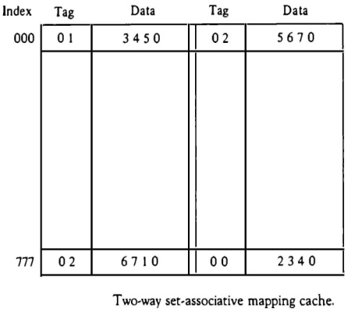Each data word is stored together with its tag and the number of tag-data items in one word of cache is said to form a set.
* Each index address refers to two data words and their associated tags. Each tag requires six bits and each data word has 12 bits, so the word length is 2(6 + 12) = 36 bits. An index address of nine bits can accommodate 512 words. Thus the size of cache memory is 512 × 36. It can accommodate 1024
* The words stored at addresses 01000 and 02000 of main memory are stored in cache memory at index address 000. Similarly, the words at addresses 02777 and 00777 are stored in cache at index address 777.
* When the CPU generates a memory request, the index value of the address is used to access the cache. The tag field of the CPU address is then compared with both tags in the cache to determine if a match occurs.
* The hit ratio will improve as the set size increases because more words with the same index but different tags can reside in cache.
* When a miss occurs in a set-associative cache and the set is full, it is necessary to replace one of the tag-data items with a new value. The most common replacement algorithms used are: random replacement, first-in first out (FIFO), and least recently used (LRU).

WRITING INTO CACHE

* An important aspect of cache organization is concerned with memory write requests. If the operation is a write, there are two ways that the system can proceed.
* The simplest and most commonly used procedure is to up data main memory with every memory write operation, with cache memory being updated in parallel if it contains the word at the specified address. This is called the ***write-through method***. This method has the advantage that main memory always contains the same data as the cache,. This characteristic is important in systems with direct memory access transfers.
* The second procedure is called the ***write-back method***. In this method only the cache location is updated during a write operation. The location is then marked by a flag so that later when the words are removed from the cache it is copied into main memory. The reason for the write-back method is that during the time a word resides in the cache, it may be updated several times; however, as long as the word remains in the cache, it does not matter whether the copy in main memory is out of date, since requests from the word are filled from the cache. It is only when the word is displaced from the cache that an accurate copy need be rewritten into main memory. CACHE INITIALIZATION
* The cache is initialized when power is applied to the computer or when the main memory is loaded with a complete set of programs from auxiliary memory. After initialization the cache is considered to be empty, built in effect it contains some non-valid data. It is customary to include with each word in cache a valid bit to indicate whether or not the word contains valid data.
* The cache is initialized by clearing all the valid bits to 0. The valid bit of a particular cache word is set to 1 the first time this word is loaded from main memory and stays set unless the cache has to be initialized again. The introduction of the valid bit means that a word in cache is initialization condition has the effect of forcing misses from the cache until it fills with valid data.

# VIRTUAL MEMORY

* In a memory hierarchy system, programs and data are brought into main memory as they are needed by the CPU.
* Virtual memory is a concept used in some large computer systems that permit the user to construct programs as though a large memory space were available, equal to the totality of auxiliary memory.
* A virtual memory system provides a mechanism for translating program-generated addresses into correct main memory locations. This is done dynamically, while programs are being executed in the CPU. The translation or mapping is handled automatically by the hardware by means of a mapping table.

## ADDRESS SPACE AND MEMORY SPACE

* An address used by a programmer will be called a virtual address, and the set of such addresses the address space.
* An address in main memory is called a location or physical address. The set of such locations is called the memory space.
* In most computers the address and memory spaces are identical. The address space is allowed to be larger than the memory space in computers with virtual memory.
* As an illustration, consider a computer with a main-memory capacity of 32K words (K =1024). Fifteen bits are needed to specify a physical address in memory since 32K = 215. Suppose that the computer has available auxiliary memory for storing 220 = 1024K words. Thus auxiliary memory has a capacity for storing information equivalent to the capacity of 32 main memories.
* Denoting the address space by N and the memory space by M, we then have for this example N

= 1024K and M = 32K.

* In a multiprogram computer system, programs and data are transferred to and from auxiliary memory and main memory based on demands imposed by the CPU. Suppose that program 1 is currently being executed in the CPU. Program 1 and a portion of its associated data is moved from auxiliary memory into main memory as shown in Fig.

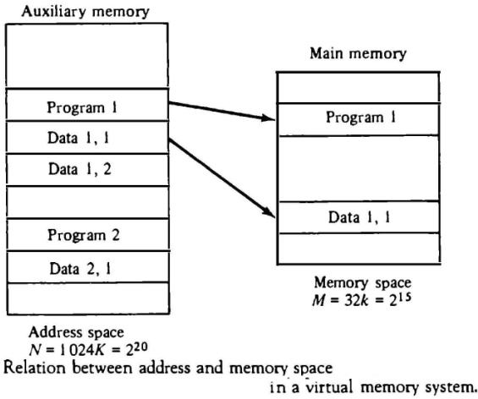

* Portions of programs and data need not be in contiguous locations in memory since information is being moved in and out, and empty spaces may be available in scattered locations in memory.
* 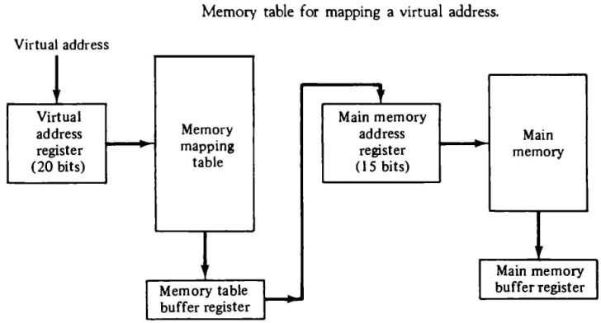The address field of an instruction code will consist of 20 bits but physical memory addresses must be specified with only 15 bits.
* A table is then needed, to map a virtual address of 20 bits to a physical address of 15 bits. The mapping is a dynamic operation,

which means that every address is translated immediately as a word is referenced by CPU.

* The mapping table may be stored in a separate memory or in main memory. In the first case, an additional memory unit is required as well as one extra memory access time. In the second case, the table takes space from main memory and two accesses to memory are required with the program running at half speed. A third alternative is to use an associative memory.

## ADDRESS MAPPING USING PAGES

* The table implementation of the address mapping is simplified if the information in the address space and the memory space are each divided into groups of fixed size. The physical memory is broken down into groups of equal size called **blocks**, which may range from 64 to 4096 words each. The term **page** refers to groups of address space of the same size.
* A page refers to the organization of address space, while a block refers to the organization of memory space. The programs are also considered to be split into pages. Portions of programs are moved from auxiliary memory to main memory in records equal to the size of a page. The term “page frame” is sometimes used to denote a block.

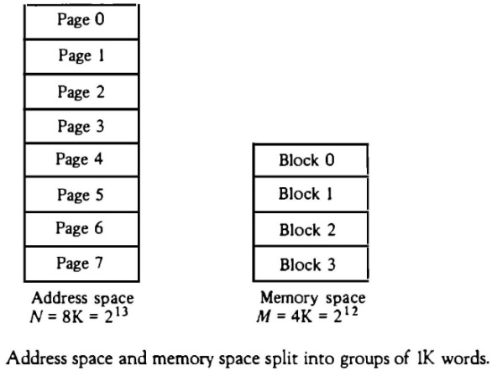Consider a computer with an address space of 8K and a memory space of 4K. If we split each into groups of 1K words we obtain eight pages and four blocks as shown in Fig.

* At any given time, up to four pages of address space may reside in main memory in any one of the four blocks.
* The mapping from address space to memory space is facilitated if each virtual address is considered to be

represented by two numbers: a page number address and a line within the page.

* In a computer with 2p words per page, p bits are used to specify a line address and the remaining high-order bits of the virtual address specify the page number.
* Note that the line address in address space and memory space is the same; the only mapping required is from a page number to a block number
* The organization of the memory mapping table in a paged system is shown in Fig.
* 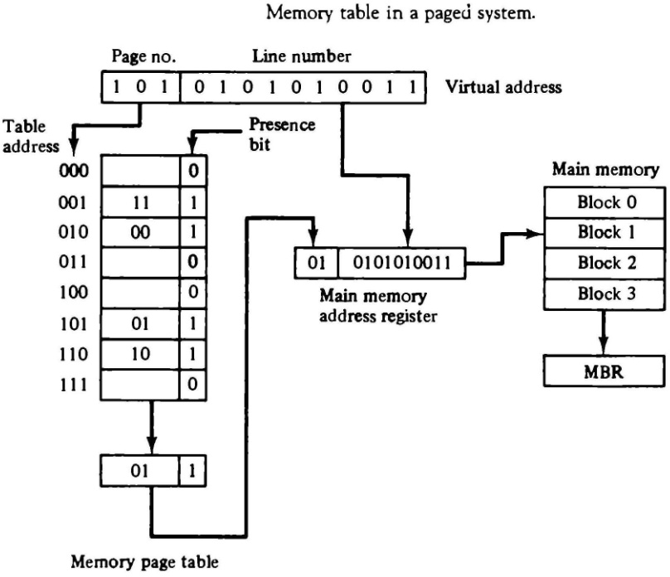The memory-page table consists of eight words, one for each page. The address in the page table denotes the page number and the content of the word gives the block number where that page is stored in main memory. The table shows that pages 1, 2, 5 and 6 are now available in main memory in blocks 3, 0, 1, and 2, respectively. A presence bit in each location indicates whether the page has been transferred from auxiliary memory into main memory. A 0 in the presence

bit indicates that this page is not available in main memory. The CPU references a word in memory with a virtual address of 13 bits. The three high-order bits of the virtual address specify a page number and also an address for the memory-page table. The content of the word in the memory page table at the page number address is read out into the memory table buffer register. If the presence bit is a 1, the block number thus read is transferred to the two high-order bits of the main memory address register. The line number from the virtual address is transferred into the 10 low order bits of the memory address register. A read signal to main memory transfers the content of the word to the main memory buffer register ready to be used by the CPU. If the presence bit in the word read from the page table is 0, it signifies that the content of the word referenced by the virtual address does not reside in main memory. A call to the operating system is then generated to fetch the required page from auxiliary memory and place it into main memory before resuming computation.

## ASSOCIATIVE MEMORY PAGE TABLE

* A random-access memory page table is inefficient with respect to storage utilization.
* In general, system with n pages and m blocks would require a memory page table of n locations of which up to m blocks will be marked with block numbers and all others will be empty.
* Consider an address space of 1024K words and memory space of 32K words. If each page or block contains 1K words, the number of pages is 1024 and the number of blocks 32. The capacity of the memory-page table must be 1024 words and only 32 locations may have a presence bit equal to 1. At any given time, at least 992 locations will be empty and not in use.
* A more efficient way to organize the page table would be to construct it with a number of words equal to the number of blocks in main memory.
* This method can be implemented by means of an associative memory with each word in memory containing a page number together with its corresponding block number. The page field in each word is compared with the page number in the virtual address. If a match occurs, the word is read from memory and its corresponding block number is extracted.
* Consider the case of eight pages and four blocks.
* 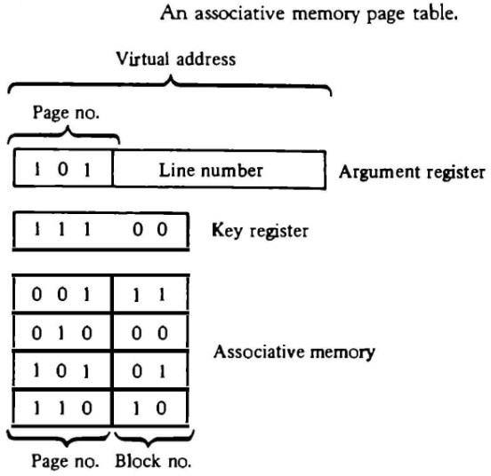Each entry in the associative memory array consists of two fields. The first three bits specify a field for storing the page number. The last two bits constitute a field for storing the block number. The virtual address is placed in the argument register. The page number bits in the argument are compared with all page numbers in the page field of the associative memory. If the page number is found, the 5-bit word is read out from memory. The corresponding block number, being in the same word, is transferred to the main memory address

register. If no match occurs, a call to the operating system is generated to bring the required page from auxiliary memory.

## PAGE REPLACEMENT

* A virtual memory system is a combination of hardware and software techniques. The memory management software system handles all the software operations for the efficient utilization of memory space. It must decide (1) which page in main memory ought to be removed to make room for a new page, (2) when a new page is to be transferred from auxiliary memory to main memory, and (3) where the page is to be placed in main memory.
* The hardware mapping mechanism and the memory management software together constitute the architecture of a virtual memory.
* When a program starts execution, one or more pages are transferred into main memory and the page table is set to indicate their position. The program is executed from main memory until it attempts to reference a page that is still in auxiliary memory. This condition is called **page fault**. When page fault occurs, the execution of the present program is suspended until the required page is brought into main memory. Since loading a page from auxiliary memory to main memory is basically an I/O operation, the operating system assigns this task to the I/O processor.
* In the meantime, controls transferred to the next program in memory that is waiting to be processed in the CPU. Later, when the memory block has been assigned and the transfer completed, the original program can resume its operation.
* When a page fault occurs in a virtual memory system, it signifies that the page referenced by the CPU is not in main memory. A new page is then transferred from auxiliary memory to main memory. If main memory is full, it would be necessary to remove a page from a memory block to make room for the new page. The policy for choosing pages to remove is determined from the replacement algorithm that is used.
* Two of the most common replacement algorithms used are the first-in first-out (FIFO) and the least recently used (LRU). The FIFO algorithm selects for replacement the page that has been in memory the longest time. Each time a page is loaded into memory, its identification number is pushed into a FIFO stack. FIFO will be full whenever memory has no more empty blocks. When a new page must be loaded, the page least recently brought in is removed. The page to be removed is easily determined because its identification number is at the top of the FIFO stack. The FIFO replacement policy has the advantage of being easy to implement. It has the disadvantages that under certain circum-stances pages are removed and loaded form memory too frequently.
* The LRU policy is more difficult to implement but has been more attractive on the assumption that the least recently used page is a better candidate for removal than the least recently loaded pages in FIFO. The LRU algorithm can be implemented by associating a counter with every page that is in main memory. When a page is referenced, its associated counter is set to zero. At fixed intervals of time, the counters associated with all pages presently in memory are incremented by 1. The least recently used page is the page with the highest count. The counters are often called aging registers, as their count indicates their age, that is, how long ago their associated pages have been referenced.

**INPUT OUTPUT ORGANIZATION**

# PERIPHERAL DEVICES

* The input-output subsystem of a computer, referred to as I/O, provides an efficient mode of communication between the central system and the outside environment
* Input or output devices attached to the computer are also called peripherals.
* Input Devices

Keyboard

Optical input devices

* + Card Reader
  + Bar code reader
  + Digitizer
  + Optical Mark Reader Screen Input Devices
  + Touch Screen
  + Light Pen
  + Mouse

Analog Input Devices

* Output Devices

CRT

Printer (Impact, Ink Jet, Laser, Dot Matrix) Plotter

Speakers

* Input and output devices that communicate with people and the computer are usually involved in the transfer of alphanumeric information to and from the device and the computer is **ASCII** (American Standard Code for Information Interchange).
* ASCII is a 7 bit code, but most computers manipulate an 8-bit quantity as a single unit called a byte. Therefore, ASCII characters most often are stored one per byte.

# INPUT-OUTPUT INTERFACE

* Input-output interface provides a method for transferring information between internal storage and external I/O devices. Peripherals connected to a computer need special communication links for interfacing them with the central processing unit. The purpose of the communication link is to resolve the differences that exist between the central computer and each peripheral. The major differences are:
  1. Peripherals are electromechanical and electromagnetic devices and their manner of operation is different from the operation of the CPU and memory, which are electronic devices. Therefore, a conversion of signal values may be required.
  2. The data transfer rate of peripherals is usually slower than the transfer rate of the CPU, and consequently, a synchronization mechanism may be need.
  3. Data codes and formats in peripherals differ from the word format in the CPU and memory.
  4. The operating modes of peripherals are different from each other and each must be controlled so as not to disturb the operation of other peripherals connected to the CPU.
* To resolve these differences, computer systems include special hardware components between the CPU and peripherals to supervise and synchronize all input and output transfers. These components are called interface units because they interface between the processor bus and the peripheral device. In addition, each device may have its own controller that supervises the operations of the particular mechanism in the peripheral.

## I/O BUS AND INTERFACE MODULES

* A typical communication link between the processor and several peripherals is shown in Fig.
* The I/O bus consists of data lines, address lines, and control lines.
* 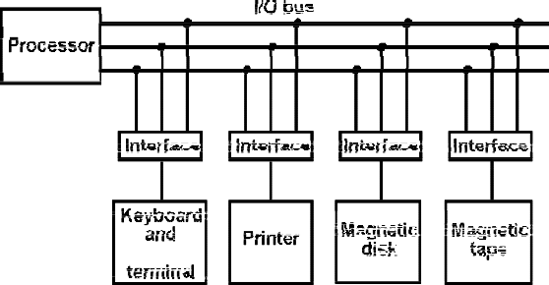Each peripheral device has associated with it an interface unit. Each interface decodes the address and control received from the I/O bus, interprets them for the peripheral, and provides signals for the peripheral controller. It also synchronizes the data

flow and supervises the transfer between peripheral and processor. Each peripheral has its own controller that operates the particular electromechanical device.

* To communicate with a particular device, the processor places a device address on the address lines. Each interface attached to the I/O bus contains an address decoder that monitors the address lines. When the interface detects its own address, it activates the path between the bus lines and the device that it controls. All peripherals whose address does not correspond to the address in the bus are disabled their interface.



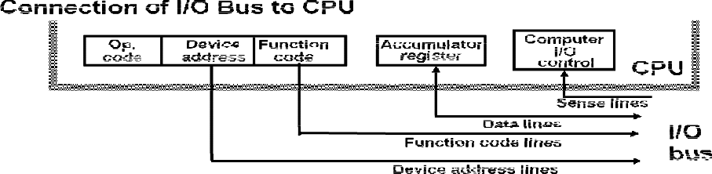

* At the same time the processor provides a function code in the control lines.

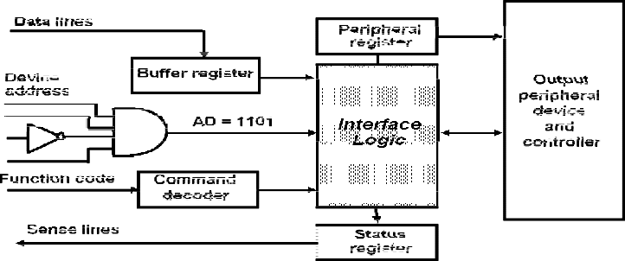

* There are four types of commands that an interface may receive. They are classified as control, status, data output, and data input.
* A control command is issued to activate the peripheral and to inform it what to do.
* A status command is used to test various status conditions in the interface and the peripheral.
* A data output command causes the interface to respond by transferring data from the bus into one of its registers.
* The data input command is the opposite of the data output. In this case the interface receives an item of data from the peripheral and places it in its buffer register.

## I/O VERSUS MEMORY BUS

* In addition to communicating with I/O, the processor must communicate with the memory unit. Like the I/O bus, the memory bus contains data, address, and read/write control lines. There are three ways that computer buses can be used to communicate with memory and I/O:

1. Use two separate buses, one for memory and the other for I/O.
2. Use one common bus for both memory and I/O but have separate control lines for each.
3. Use one common bus for memory and I/O with common control lines.

In the first method, the computer has independent sets of data, address, and control buses, one for accessing memory and the other for I/O. This is done in computers that provide a separate I/O processor (IOP) in addition to the central processing unit (CPU). The memory communicates with both the CPU and the IOP through a memory bus. The IOP communicates also with the input and output devices through a separate I/O bus with its own address, data and control lines. The purpose of the IOP is to provide an independent pathway for the transfer of information between external devices and internal memory

## ISOLATED VERSUS MEMORY-MAPPED I/O

* Many computers use one common bus to transfer information between memory or I/O and the CPU. The distinction between a memory transfer and I/O transfer is made through separate read and write lines. The CPU specifies whether the address on the address lines is for a memory word or for an interface register by enabling one of two possible read or write lines. The I/O read and I/O write control lines are enabled during an I/O transfer. The memory read and memory write control lines are enabled during a memory transfer.
* In the **isolated I/O** configuration, the CPU has distinct input and output instructions, and each of these instructions is associated with the address of an interface register. When the CPU fetches and decodes the operation code of an input or output instruction, it places the address associated with the instruction into the common address lines. At the same time, it enables the I/O read (for input) or I/O write (for output) control line. This informs the external components that are attached to the common bus that the address in the address lines is for an interface register and not for a memory word. On the other hand, when the CPU is fetching an instruction or an operand from memory, it places the memory address on the address lines and enables the memory read or memory write control line. This informs the external components that the address is for a memory word and not for an I/O interface.
* The other alternative is to use the same address space for both memory and I/O. This is the case in computers that employ only one set of read and write signals and do not distinguish between memory and I/O addresses. This configuration is referred to as **memory mapped I/O**. The computer treats an interface register as being part of the memory system.
* In a memory-mapped I/O organization there is no specific input or output instructions. The CPU can manipulate I/O data residing in interface registers with the same instructions that are used to manipulate memory words. Each interface is organized as a set of registers that respond to read and write requests in the normal address space. Typically, a segment of the total address space is reserved for interface registers, but in general, they can be located at any address as long as there is not also a memory word that responds to the same address.
* Computers with memory-mapped I/O can use memory-type instructions to access I/O data. It allows the computer to use the same instructions for either input-output transfers or for memory transfers.
* The advantage is that the load and store instructions used for reading and writing from memory can be used to input and output data from I/O registers.
* In a typical computer, there are more memory-reference instructions than I/O instructions. With memory mapped I/O all instructions that refer to memory are also available for I/O. .

## EXAMPLE OF I/O INTERFACE

* An example of an I/O interface unit is shown in block diagram

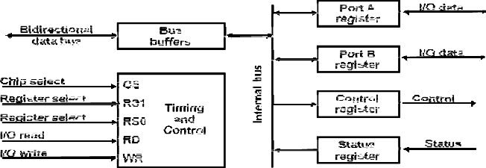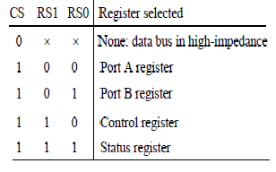

* It consists of two data registers called ports, a control register, a status register, bus buffers, and timing and control circuits. The interface communicates with the CPU through the data bus.
* The chip select and register select inputs determine the address assigned to the interface. The I/O read and write are two control lines that specify an input or output, respectively.
* The four registers communicate directly with the I/O device attached to the interface. The I/O data to and from the device can be transferred into either port A or Port B.
* The interface may operate with an output device or with an input device, or with a device that requires both input and output..
* A command is passed to the I/O device by sending a word to the appropriate interface register. In a system like this, the function code in the I/O bus is not needed because control is sent to the control register, status information is received from the status register, and data are transferred to and from ports A and B registers. Thus the transfer of data, control, and status information is always via the common data bus.
* The distinction between data, control, or status information is determined from the particular register with which the CPU communicates.
* The control register receives control information from the CPU. By loading appropriate bits into the control register, the interface and the I/O device attached to it can be placed in a variety of operating modes.
* The interface registers communicate with the CPU through the bidirectional data bus.
* The address bus selects the interface unit through the chip select and the two register select inputs. A circuit must be provided externally (usually, a decoder) to detect the address assigned to the interface registers. This circuit enables the chip select (CS) input when the interface is selected by the address bus. The two register select inputs RS1 and RS0 are usually connected to the two least significant lines of the lines address bus. These two inputs select one of the four registers in the interface as specified in the table accompanying the diagram.
* The content of the selected register is transfer into the CPU via the data bus when the I/O read signal is enabled. The CPU transfers binary information into the selected register via the data bus when the I/O write input is enabled.

# ASYNCHRONOUS DATA TRANSFER

* The internal operations in a digital system are synchronized by means of clock pulses supplied by a common pulse generator.
* If the registers in the interface share a common clock with the CPU registers, the transfer between the two units is said to be synchronous.
* In most cases, the internal timing in each unit is independent from the other in that each uses its own private clock for internal registers. In that case, the two units are said to be asynchronous to each other.
* Asynchronous data transfer between two independent units requires that control signals be transmitted between the communicating units to indicate the time at which data is being transmitted.
* One way of achieving this is by means of a **strobe pulse** supplied by one of the units to indicate to the other unit when the transfer has to occur. Another method commonly used is to accompany each data item being transferred with a control signal that indicates the presence of data in the bus. The unit receiving the data item responds with another control signal to acknowledge receipt of the data. This type of agreement between two independent units is referred to as **handshaking.**

## STROBE CONTROL

* The strobe control method of asynchronous data transfer employs a single control line to time each transfer. The strobe may be activated by either the source or the destination unit.
* 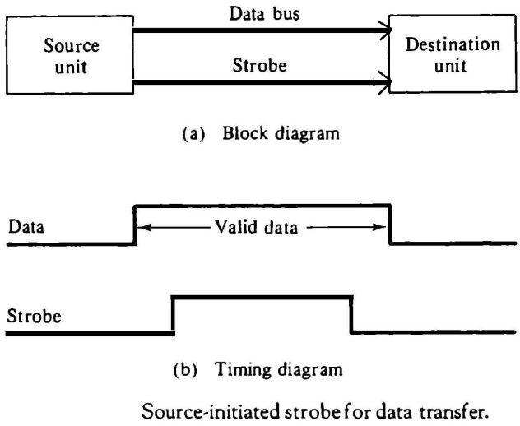The data bus carries the binary information from source unit to the destination unit. Typically, the bus has multiple lines to transfer an entire byte or word. The strobe is a single line that informs the destination unit when a valid data word is available in the bus.
* As shown in the timing diagram the source unit first places the data on the data bus. After a brief delay to ensure that the data settle to a steady value, the source activates the strobe pulse.
* The information on the data bus and the strobe signal remain in the active state for a sufficient time period to allow the destination unit to receive the data. Often, the destination unit uses the falling edge of the strobe pulse to transfer the contents of the data bus into one of its internal registers.
* The following Figure shows a data transfer initiated by the destination unit.
* 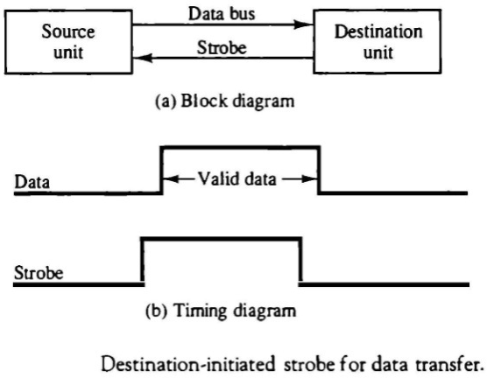In this case the destination unit activates the strobe pulse, informing the source to provide the data. The source unit responds by placing the requested binary information on the data bus. The data must be valid and remain in the bus long enough for the destination unit to accept it. The falling edge of the strobe pulse can be used again to trigger a destination register. The destination unit then disables the strobe
* The transfer of data between the CPU and an interface unit is similar to the strobe transfer. Data transfer between an interface and an I/O device is commonly controlled by a set of handshaking lines

## HANDSHAKING

* The disadvantage of the strobe method is that the source unit that initiates the transfer has no way of knowing whether the destination unit has actually received the data item that was placed in the bus. Similarly, a destination unit that initiates the transfer has no way of knowing whether the source unit has actually placed the data on the bus. The handshake method solves this problem by introducing a second control signal that provides a reply to the unit that initiates the transfer.
* The basic principle of the handshaking method of data transfer is as follows. One control line is in the same direction as the data flow in the bus from the source to the destination. It is used by the source unit to inform the destination unit whether there are valued data in the bus.
* The other control line is in the other direction from the destination to the source. It is used by the destination unit to inform the source whether it can accept data. The sequence of control during the transfer depends on the unit that initiates the transfer.
* The two handshaking lines are **data valid,** which is generated by the source unit, and **data accepted,** generated by the destination unit.
* The timing diagram shows the exchange of signals between the two units. In the destination- initiated transfer the source does not place data on the bus until after it receives the ready for data signal from the destination unit.
* The handshaking scheme provides a high degree of flexibility and reality because the successful completion of a data transfer relies on active participation by both units. If one unit is faulty, the data transfer will not be completed. Such an error can be detected by means of a timeout mechanism, which produces an alarm if the data transfer is not completed within a predetermined time. The timeout is implemented by means of an internal clock that starts

counting time when the unit enables one of its handshaking control signals. If the return handshake signal does not respond within a given time period, the unit assumes that an error has occurred

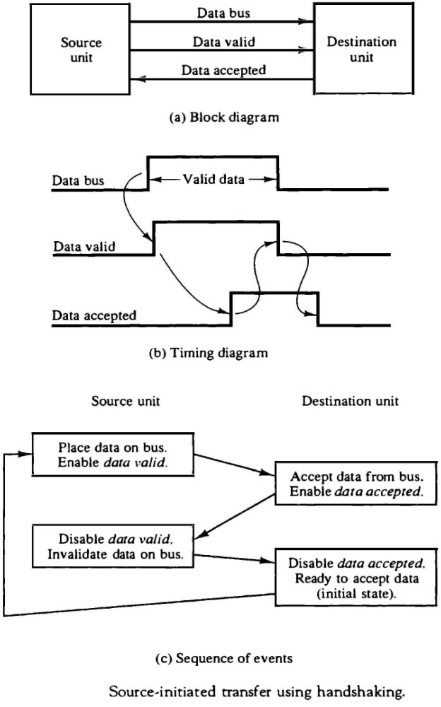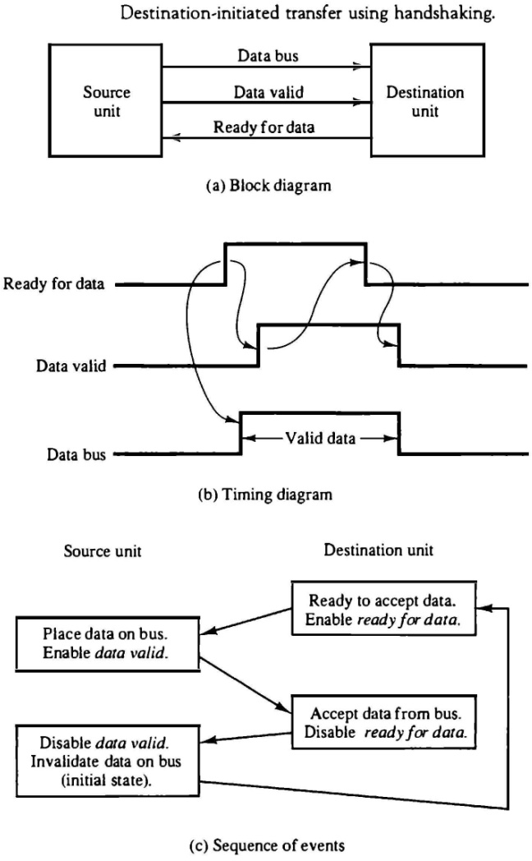

## ASYNCHRONOUS SERIAL TRANSFER

* The transfer of data between two units may be done in parallel or serial. In parallel data transmission, each bit of the message has its own path and the total message is transmitted at the same time.
* In serial data transmission, each bit in the message is sent in sequence one at a time.
* Parallel transmission is faster but requires many wires. It is used for short distances and where speed is important. Serial transmission is slower but is less expensive since it requires only one pair of conductors.
* Serial transmission can be synchronous or asynchronous. In synchronous transmission, the two units share a common clock frequency and bits are transmitted continuously at the rate dictated by the clock pulses. In long-distant serial transmission, each unit is driven by a separate clock of the same frequency. Synchronization signals are transmitted periodically between the two units to keep their clocks in step with each other.
* In asynchronous transmission, binary information is sent only when it is available and the line remains idle when there is no information to be transmitted.
* Serial asynchronous data transmission technique used in many interactive terminals employs special bits that are inserted at both ends of the character code. With this technique, each character consists of three parts: a start bit, the character bits, and stop bits.
* The convention is that the transmitter rests at the 1-state when no characters are transmitted. The first bit, called the start bit, is always a 0 and is used to indicate the beginning of a character. The last bit called the stop bit is always a 1.
* An example of this format is shown in Fig.

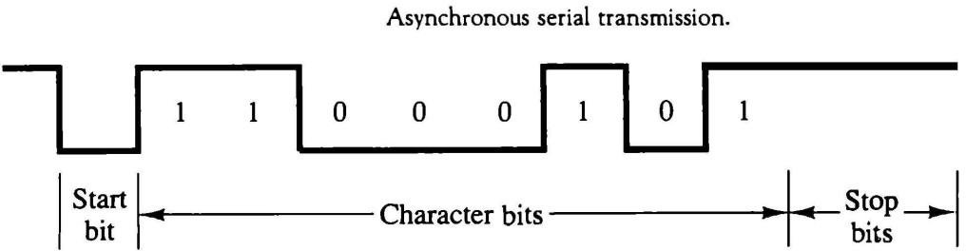

* A transmitted character can be detected by the receiver from knowledge of the transmission rules:

1. When a character is not being sent, the line is kept in the 1-state.
2. The initiation of a character transmission is detected from the start bit, which is always 0.
3. The character bits always follow the start bit.
4. After the last bit of the character is transmitted, a stop bit is detected when the line returns to the 1-state for at least one bit time.

* Using these rules, the receiver can detect the start bit when the line gives from 1 to 0. A clock in the receiver examines the line at proper bit times. The receiver knows the transfer rate of the bits and the number of character bits to accept. After the character bits are transmitted, one or two stop bits are sent. The stop bits are always in the 1-state and frame the end of the character to signify the idle or wait state.
* At the end of the character the line is held at the 1-state for a period of at least one or two bit times so that both the transmitter and receiver can resynchronize. The length of time that the line stays in this state depends on the amount of time required for the equipment to resynchronize.
* Some older electromechanical terminals use two stop bits, but newer terminals use one stop bit.
* The line remains in the 1-state until another character is transmitted. The stop time ensures that a new character will not follow for one or two bit times.

## Asynchronous Communication Interface

* The block diagram of an asynchronous communication interface is shown in Fig.

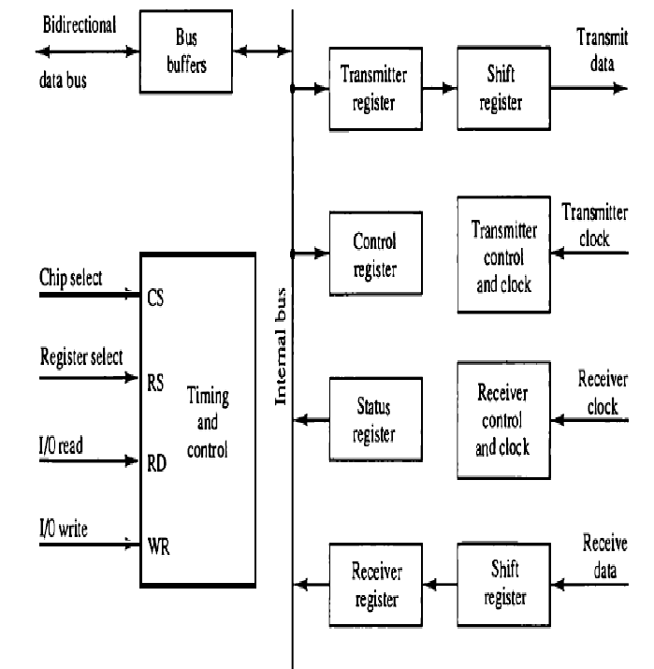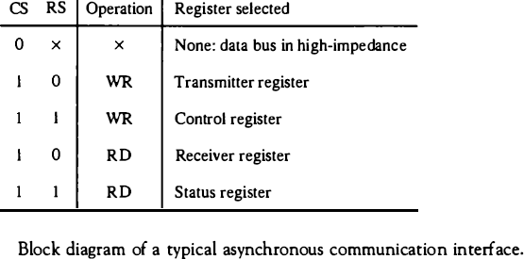

* It functions as both a transmitter and a receiver. The interface is initialized for a particular mode of transfer by means of a control byte that is loaded into its control register. The transmitter register accepts a data byte from the CPU through the data bus. This byte is transferred to a shift register for serial transmission. The receiver portion receives serial information into another shift register, and when a complete data byte is accumulated, it is transferred to the receiver register. The CPU can select the receiver register to read the byte through the data bus.
* The bits in the status register are used for input and output flags and for recording certain errors that may occur during the transmission. The CPU can read the status register to check the status of the flag bits and to determine if any errors have occurred.
* The chip select and the read and write control lines communicate with the CPU. The chip select (CS) input is used to select the interface through the address bus. The register select (RS) is associated with the read (RD) and write (WR) controls. Two registers are write-only and two are read-only. The register selected is a function of the RS value and the RD and WR status, as listed in the table accompanying the diagram.
* The operation of the asynchronous communication interface is initialized by the CPU by sending a byte to the control register. The initialization procedure places the interface in a specific mode of operation as it defines certain parameters such as the baud rate to use, how many bits are in each character, whether to generate and check parity, and how many stop bits

are appended to each character. Two bits in the status register are used as flags. One bit is used to indicate whether the transmitter register is empty and another bit is used to indicate whether the receiver register is full.

* The operation of the transmitter portion of the interface is as follows. The CPU reads the status register and checks the flag to see if the transmitter register is empty. If it is empty, the CPU transfers a character to the transmitter register and the interface clears the flag to mark the register full. The first bit in the transmitter shift register is set to 0 to generate a start bit. The character is transferred in parallel from the transmitter register to the shift register and the appropriate number of stop bits are appended into the shift register. The transmitter register is then marked empty. The character can now be transmitted one bit at a time by shifting the data in the shift register at the specified baud rate. The CPU can transfer another character to the transmitter register after checking the flag in the status register. The interface is said to be double buffered because a new character can be loaded as soon as the previous one starts transmission.
* The operation of the receiver portion of the interface is similar. The receive data input is in the 1-state when the line is idle. The receiver control monitors the receive-data line for a 0 signal to detect the occurrence of a start bit. Once a start bit has been detected, the incoming bits of the character are shifted into the shift register at the prescribed baud rate. After receiving the data bits, the interface checks for the parity and stop bits. The character without the start and stop bits is then transferred in parallel from the shift register to the receiver register. The flag in the status register is set to indicate that the receiver register is full. The CPU reads the status register and checks the flag, and if set, it reads the data from the receiver register. The interface checks for any possible errors during transmission and sets appropriate bits in the status register. The CPU can read the status register at any time to check if any errors have occurred. Three possible errors that the interface checks during transmission are parity error, framing error, and overrun error. Parity error occurs if the number of l's in the received data is not the correct parity. A framing error occurs if the right number of stop bits is not detected at the end of the received character. An overrun error occurs if the CPU does not read the character from the receiver register before the next one becomes available in the shift register. Overrun error results in a loss of characters in the received data stream.

## First-In, First-Out Buffer

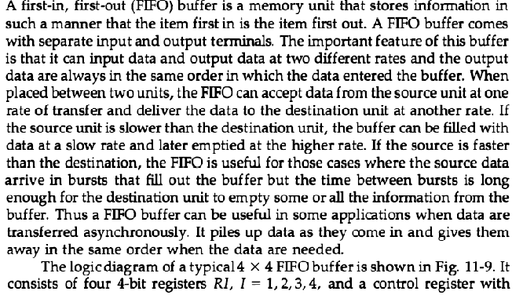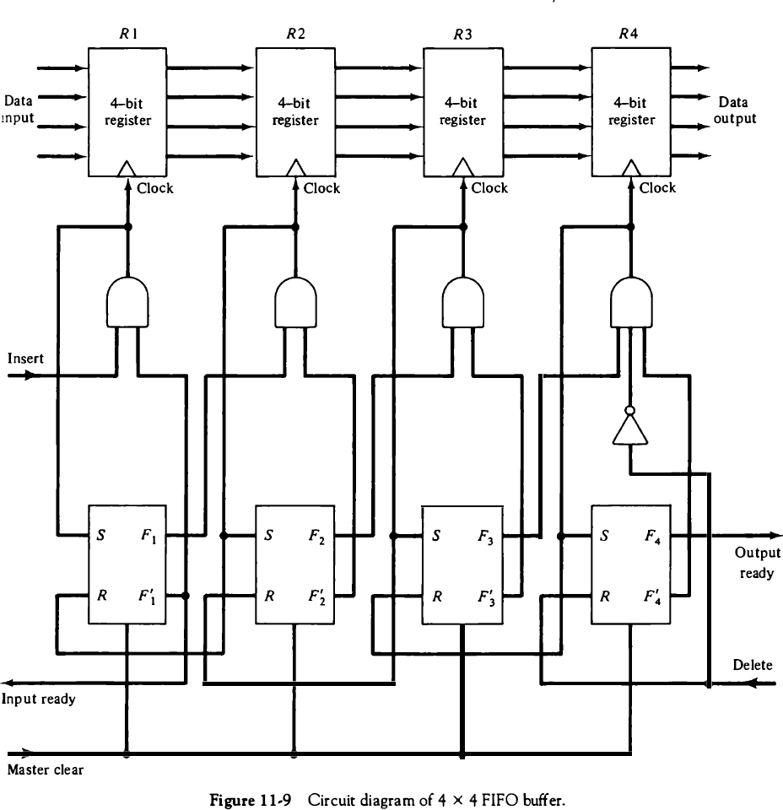

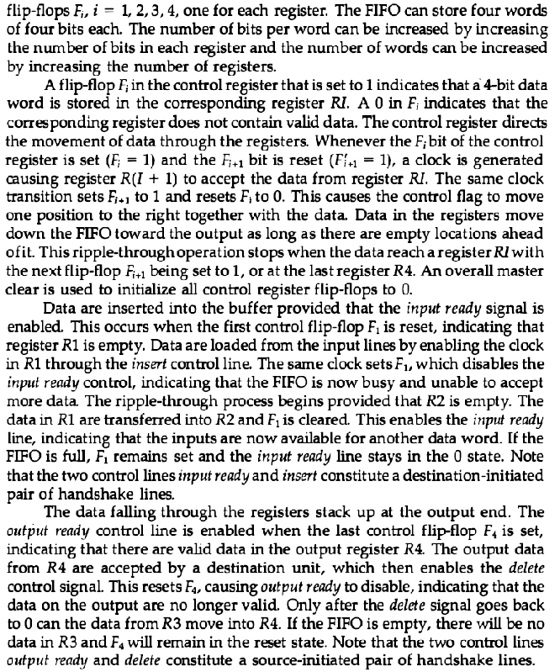

**MODES OF TRANSFER**

* Binary information received from an external device is usually stored in memory for later processing. Information transferred from the central computer into an external device originates in the memory unit. The CPU merely executes the I/O instructions and may accept the data temporarily, but the ultimate source or destination is the memory unit.
* Data transfer between the central computer and I/O devices may be handled in a variety of modes. Some modes use the CPU as an intermediate path; other transfer the data directly to and from the memory unit.
* Data transfer to and from peripherals may be handled in one of three possible modes:
  1. Programmed I/O
  2. Interrupt-initiated I/O
  3. Direct memory access (DMA)
* Programmed I/O operations are the result of I/O instructions written in the computer program. Each data item transfer is initiated by an instruction in the program. Usually, the transfer is to and from a CPU register and peripheral. Other instructions are needed to transfer the data to and from CPU and memory. Transferring data under program control requires constant monitoring of the peripheral by the CPU. Once a data transfer is initiated, the CPU is required to monitor the interface to see when a transfer can again be made. It is up to the programmed instructions executed in the CPU to keep close tabs on everything that is taking place in the interface unit and the I/O device.
* In the programmed I/O method, the CPU stays in a program loop until the I/O unit indicates that it is ready for data transfer. This is a time-consuming process since it keeps the processor busy needlessly. It can be avoided by using an interrupt facility and special commands to inform the interface to issue an interrupt request signal when the data are available from the device. In the meantime the CU can proceed to execute another program. The interface meanwhile keeps monitoring the device. When the interface determines that the device is ready for data transfer, it generates an interrupt request to the computer. Upon detecting the external interrupt signal, the CPU momentarily stops the task it is processing, branches to a service program to process the I/O transfer, and then returns to the task it was originally performing Transfer of data under programmed I/O is between CPU and peripheral.
* In direct memory access (DMA), the interface transfers data into and out of the memory unit through the memory bus. The CPU initiates the transfer by supplying the interface with the starting address and the number of words needed to be transferred and then proceeds to execute other tasks. When the transfer is made, the DMA requests memory cycles through the memory bus. When the request is granted by the memory controller, the DMA transfers the data directly

into memory. The CPU merely delays its memory access operation to allow the direct memory I/O transfer. Since peripheral speed is usually slower than processor speed, I/O-memory transfers are infrequent compared to processor access to memory.

* Many computers combine the interface logic with the requirements for direct memory access into one unit and call it an I/O processor (IOP). The IOP can handle many peripherals through a DMPA and interrupt facility. In such a system, the computer is divided into three separate modules: the memory unit, the CPU, and the IOP.

## EXAMPLE OF PROGRAMMED I/O

* In the programmed I/O method, the I/O device does not have direct access to memory. A transfer from an I/O device to memory requires the execution of several instructions by the CPU, including an input instruction to transfer the data from the device to the CPU, and a store instruction to transfer the data from the CPU to memory. Other instructions may be needed to verify that the data are available from the device and to count the numbers of words transferred.
* 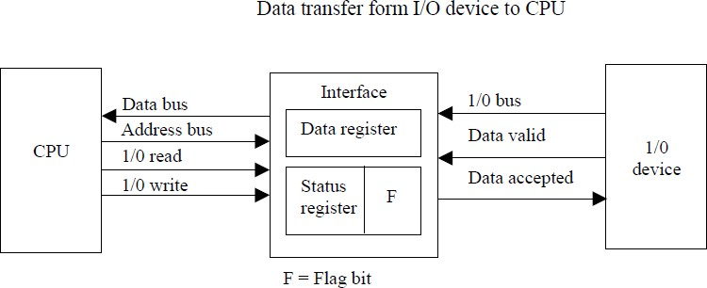An example of data transfer from an I/O device through an interface into the CPU is shown in Fig.
* The device transfers bytes of data one at a time as they are available. When a byte of data is available, the device places it in the I/O bus and enables its data valid line. The interface accepts the byte into its data register and enables the data accepted line. The interface sets a bit in the status register that we will refer to as an F or “flag” bit. The device can now disable the data valid line, but it will not transfer another byte until the data accepted line is disabled by the interface.
* A program is written for the computer to check the flag in the status register to determine if a byte has been placed in the data register by the I/O device. This is done by reading the status register into a CPU register and checking the value of the flag bit. If the flag is equal to 1, the CPU reads the data from the data register. The flag bit is then cleared to 0 by either the CPU or the interface, depending on how the interface circuits are designed. Once the flag is cleared, the interface disables the data accepted line and the device can then transfer the next data byte.

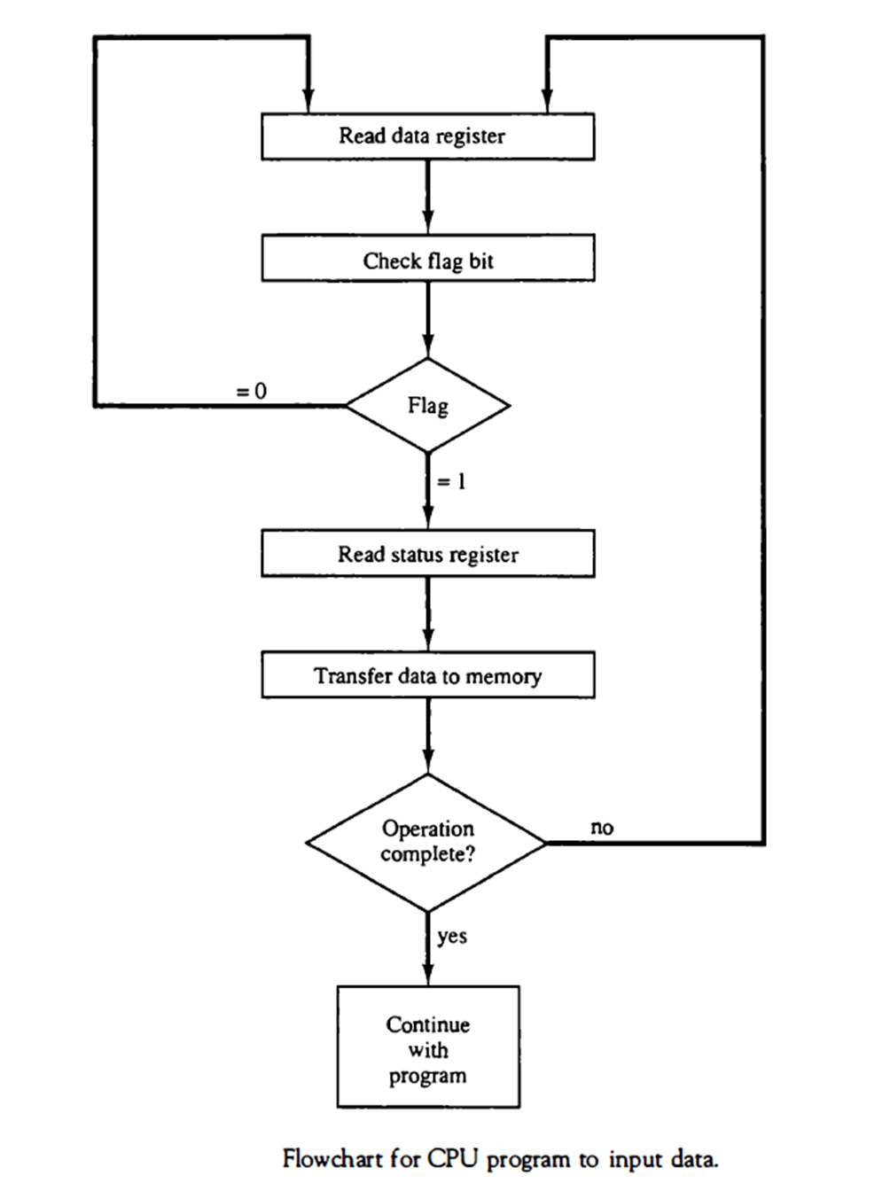

* A flowchart of the program that must be written for the CPU is shown in Fig.

It is assumed that the device is sending a sequence of bytes that must be stored in memory. The transfer of each byte requires three instructions:

1. Read the status register.
2. Check the status of the flag bit and branch to step 1 if not set or to step 3 if set.
3. Read the data register.

* Each byte is read into a CPU register and then transferred to memory with a store instruction. A common I/O programming task is to transfer a block of words form an I/O device and store them in a memory buffer.
* The programmed I/O method is particularly useful in small low-speed computers or in systems that are dedicated to monitor a device continuously. The difference in

information transfer rate between the CPU and the I/O device makes this type of transfer inefficient.

## INTERRUPT-INITIATED I/O

* An alternative to the CPU constantly monitoring the flag is to let the interface inform the computer when it is ready to transfer data. This mode of transfer uses the interrupt facility. While the CPU is running a program, it does not check the flag. However, when the flag is set, the computer is momentarily interrupted from proceeding with the current program and is informed of the fact that the flag has been set.
* The CPU deviates from what it is doing to take care of the input or output transfer. After the transfer is completed, the computer returns to the previous program to continue what it was doing before the interrupt.
* The CPU responds to the interrupt signal by storing the return address from the program counter into a memory stack and then control branches to a service routine that processes the

required I/O transfer. The way that the processor chooses the branch address of the service routine varies from tone unit to another. In principle, there are two methods for accomplishing this. One is called vectored interrupt and the other, no vectored interrupt. In a non vectored interrupt, the branch address is assigned to a fixed location in memory. In a vectored interrupt, the source that interrupts supplies the branch information to the computer. This information is called the interrupt vector. In some computers the interrupt vector is the first address of the I/O service routine. In other computers the interrupt vector is an address that points to a location in memory where the beginning address of the I/O service routine is stored.

## SOFTWARE CONSIDERATIONS

* The previous discussion was concerned with the basic hardware needed to interface I/O devices to a computer system. A computer must also have software routines for controlling peripherals and for transfer of data between the processor and peripherals. I/O routines must issue control commands to activate the peripheral and to check the device status to determine when it is ready for data transfer. Once ready, information is transferred item by item until all the data are transferred. In some cases, a control command is then given to execute a device function such as stop tape or print characters. Error checking and other useful steps often accompany the transfers.
* In interrupt-controlled transfers, the I/O software must issue commands to the peripheral to interrupt when ready and to service the interrupt when it occurs. In DMA transfer, the I/O software must initiate the DMA channel to start its operation.
* Software control of input-output equipment is a complex undertaking. For this reason I/O routines for standard peripherals are provided by the manufacturer as part of the computer system. They are usually included within the operating system. Most operating systems are supplied with a variety of I/O programs to support the particular line of peripherals offered for the computer. I/O routines are usually available as operating system procedures and the user refers to the established routines to specify the type of transfer required without going into detailed machine language programs.

## PRIORITY INTERRUPT

* Data transfer between the CPU and an I/O device is initiated by the CPU. The CPU cannot start the transfer unless the device is ready to communicate with the CPU. The readiness of the device can be determined from an interrupt signal.
* Numbers of I/O devices are attached to the computer; several sources will request service simultaneously. The first task of the interrupt system is to identify the source of the interrupt and decide which device to service first
* A priority interrupts is a system to determine which interrupt is to be served first when two or more requests are made simultaneously. Also determines which interrupts are permitted to interrupt the computer while another is being serviced. Higher priority interrupts can make requests while servicing a lower priority interrupt
* Establishing the priority of simultaneous interrupts can be done by software or hardware.
* Priority Interrupt by Software(Polling)
* Priority is established by the order of polling the devices(interrupt sources)
* Flexible since it is established by software
* Low cost since it needs a very little hardware
* Very slow
* Priority Interrupt by Hardware

- Require a priority interrupt manager which accepts all the interrupt requests to determine the highest priority request

* Fast since identification of the highest priority interrupt request is identified by the hardware. Each interrupt source has its own interrupt vector to access directly to its own service routine
* The hardware priority function can be established by either a serial or a parallel connection of interrupt lines. The serial connection is also known as the daisy chaining method.

## DAISY-CHAINING PRIORITY

* 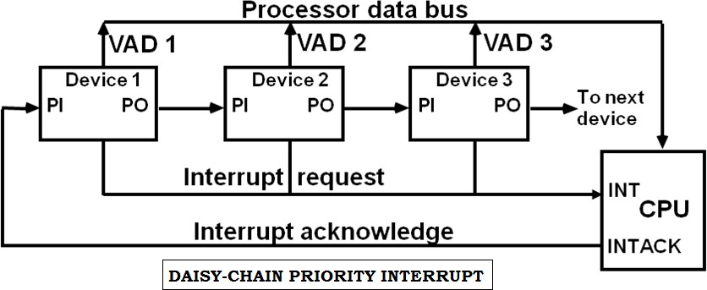The daisy-chaining method of establishing priority consists of a serial connection of all devices that request an interrupt. The device with the highest priority is placed in the first position, followed by lower-priority devices up to the device with the lowest priority, which is placed last in the chain.
* The interrupt request line is common to all devices and forms a wired logic connection. If any device has its interrupt signal in the low-level state, the interrupt line goes to the low-level state and enables the interrupt input in the CPU. When no interrupts are pending, the interrupt line stays in the high-level state and no interrupts are recognized by the CPU.
* The CPU responds to an interrupt request by enabling the interrupt acknowledge line. This signal is received by device 1 at its PI (priority in) input. The acknowledge signal passes on to the next device through the PO (priority out) output only if device 1 is not requesting an interrupt.
* If device 1 has a pending interrupt, it blocks the acknowledge signal from the next device by placing a 0 in the PO output. It then proceeds to insert its own interrupt vector address (VAD) into the data bus for the CPU to use during the interrupt cycle.
* The device with PI = 1 and PO = 0 is the one with the highest priority that is requesting an interrupt, and this device places its VAD on the data bus.
* 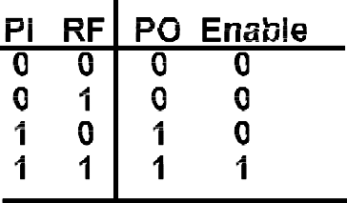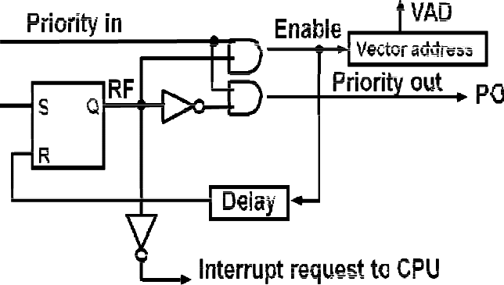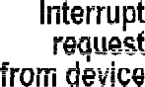The following figure shows the internal logic that must be included with in each device when connected in the daisy-chaining scheme.

Fig: One stage of the daisy- chain priority arrangement

* The device sets its RF flip-flop when it wants to interrupt the CPU. The output of the RF flip- flop goes through an open-collector inverter, a circuit that provides the wired logic for the common interrupt line.
* If PI = 0, both PO and the enable line to VAD are equal to 0, irrespective of the value of RF.
* If PI = 1 and RF = 0, then PO = 1 and the vector address is disabled. This condition passes the acknowledge signal to the next device through PO.
* The device is active when PI = 1 and RF = 1. This condition places a 0 in PO and enables the vector address for the data bus. It is assumed that each device has its own distinct vector address.
* The RF flip-flop is reset after a sufficient delay to ensure that the CPU has received the vector address.

## PARALLEL PRIORITY INTERRUPT

* The parallel priority interrupt method uses a register whose bits are set separately by the interrupt signal from each device.
* Priority is established according to the position of the bits in the register. In addition to the interrupt register the circuit may include a mask register whose purpose is to control the status of each interrupt request.
* The mask register can be programmed to disable lower-priority interrupts while a higher- priority device is being serviced. It can also provide a facility that allows a high-priority device to interrupt the CPU while a lower-priority device is being serviced.
* The priority logic for a system of four interrupt sources is shown in Fig.

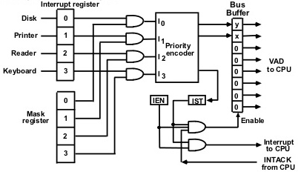

* It consists of an interrupt register whose individual bits are set by external conditions and cleared by program instructions.
* The mask register has the same number of bits as the interrupt register. By means of program instructions, it is possible to set or reset any bit in the mask register.
* Each interrupt bit and its corresponding mask bit are applied to an AND gate to produce the four inputs to a priority encoder. In this way an interrupt is recognized only if its corresponding mask bit is set to 1 by the program.
* The priority encoder generates two bits of the vector address, which is transferred to the CPU.
* Another output from the encoder sets an interrupt status flip-flop IST when an interrupt that is not masked occurs.
* The interrupt enable flip-flop IEN can be set or cleared by the program to provide an overall control over the interrupt system.
* The outputs of IST ANDed with IEN provide a common interrupt signal for the CPU.
* The interrupt acknowledge INTACK signal from the CPU enables the bus buffers in the output register and a vector address VAD is placed into the data bus.

## Priority Encoder

* The priority encoder is a circuit that implements the priority function. The logic of the priority encoder is such that if two or more inputs arrive at the same time, the input having the highest priority will take precedence.

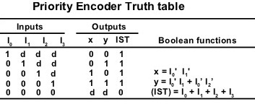

## Interrupt Cycle

* The interrupt enable flip-flop IEN can be set or cleared by program instructions.
* When IEN is cleared, the interrupt request coming from IST is neglected by the CPU.
* The program-controlled IEN bit allows the programmer to choose whether to use the interrupt facility. If an instruction to clear IEN has been inserted in the program, it means that the user does not want his program to be interrupted. An instruction to set IEN indicates that the interrupt facility will be used while the current program is running.
* Most computers include internal hardware that clears IEN to 0 every time an interrupt is acknowledged by the processor
* At the end of each instruction cycle the CPU checks IEN and the interrupt signal from IST. If either is equal to 0, control continues with the next instruction.
* If both IEN and IST are equal to 1, the CPU goes to an interrupt cycle.
* During the interrupt cycle the CPU performs the following sequence of microoperations: SP ← SP-1 Decrement stack pointer

M[SP] ←PC Push PC into stack

INTACK ←1 Enable interrupt acknowledge PC ← VAD Transfer vector address to PC

lEN ←0 Disable further interrupts Go to fetch next instruction

## Software Routines

* A priority interrupt system is a combination of hardware and software techniques
* The following figure shows the programs that must reside in memory for handling the interrupt system.

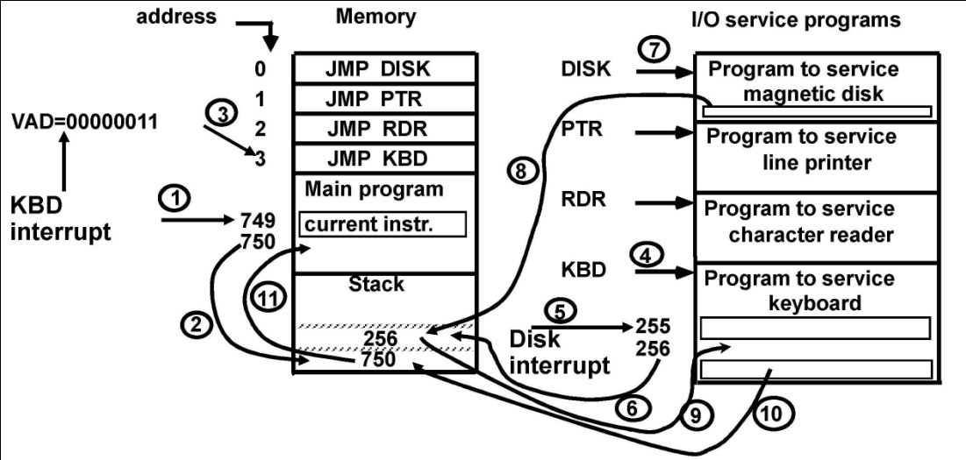

## Initial and Final Operations

* Each interrupt service routine must have an initial and final set of operations for controlling the registers in the hardware interrupt system

## Initial Sequence

1. Clear lower level Mask reg. bits
2. IST ←0
3. Save contents of CPU registers
4. IEN←1
5. Go to Interrupt Service Routine

## Final Sequence

1. IEN ←0
2. Restore CPU registers
3. Clear the bit in the Interrupt Reg
4. Set lower level Mask reg. bits
5. Restore return address into PC, and IEN ←1

* The initial and final operations are referred to as **overhead operations** or **housekeeping chores**. They are not part of the service program proper but are essential for processing interrupts.
* All overhead operations can be implemented by software. This is done by inserting the proper instructions at the beginning and at the end of each service routine. Some of the overhead operations can be done automatically by the hardware

# DIRECT MEMORY ACCESS (DMA):

* The transfer of data between a fast storage device such as magnetic disk and memory is often limited by the speed of the CPU. Removing the CPU from the path and letting the peripheral device manage the memory buses directly would improve the speed of transfer. This transfer technique is called **direct memory access (DMA)**.
* During DMA transfer, the CPU is idle and has no control of the memory buses.
* A DMA controller takes over the buses to manage the transfer directly between the I/O device and memory.
* 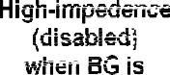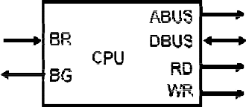The CPU may be placed in an idle state in a variety of ways. One common method extensively used in microprocessors is to disable the buses through special control signals.



* The bus request (BR) input is used by the DMA controller to request the CPU to cease control of the buses. When this input is active, the CPU terminates the execution of the current instruction and places the address bus, the data bus, and the read and write lines into a high- impedance state behaves like an open circuit, which means that the output is disconnected and does not have a logic significance.
* The CPU activates the Bus grant (BG) output to inform the external DMA that the buses are in the high-impedance state. The DMA that originated the bus request can now take control of the buses to conduct memory transfers without processor intervention. When the DMA terminates the transfer, it disables the bus request line. The CPU disables the bus grant, takes control of the buses, and returns to its normal operation.
* When the DMA takes control of the bus system, it communicates directly with the memory. The transfer can be made in several ways. In DMA **burst transfer**, a block sequence consisting of a number of memory words is transferred in a continuous burst while the DMA controller is master of the memory buses. This mode of transfer is needed for fast devices such as magnetic disks, where data transmission cannot be stopped or slowed down until an entire block is transferred.
* An alternative technique called **cycle stealing** allows the DMA controller to transfer one data word at a time after which it must return control of the buses to the CPU. The CPU merely delays its operation for one memory cycle to allow the direct memory I/O transfer to “steal” one memory cycle.

## DMA CONTROLLER

* The following figure shows the block diagram of a typical DMA controller



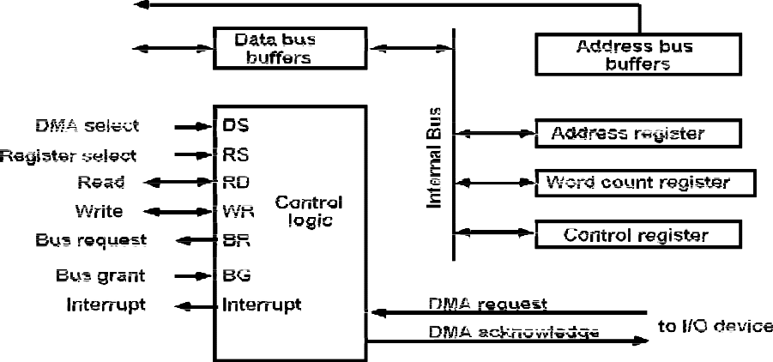

* The unit communicates with the CPU via the data bus and control lines. The registers in the DMA are selected by the CPU through the address bus by enabling the DS (DMA select) and RS (register select) inputs. The RD (read) and WR (write) inputs are bidirectional.
* When the BG (bus grant) input is 0, the CPU can communicate with the DMA registers through the data bus to read from or write to the DMA registers.
* When BG = 1, the CPU has relinquished(ceased) the buses and the DMA can communicate directly with the memory by specifying an address in the address bus and activating the RD or WR control.
* The DMA communicates with the external peripheral through the request and acknowledge lines by using a prescribed handshaking procedure.
* The DMA controller has three registers: an address register, a word count register, and a control register. The address register contains an address to specify the desired location in memory. The address bits go through bus buffers into the address bus. The address register is incremented after each word that is transferred to memory.
* The word count register is incremented after each word that is transferred to memory. The word count register holds the number of words to be transferred. This register is decremented by one after each word transfer and internally tested for zero.
* The control register specifies the mode of transfer. All registers in the DMA appear to the CPU as I/O interface registers. Thus the CPU can read from or write into the DMA registers under program control via the data bus.
* The DMA is first initialized by the CPU. After that, the DMA starts and continues to transfer data between memory and peripheral unit until an entire block is transferred. The initialization process is essentially a program consisting of I/O instructions that include the address for

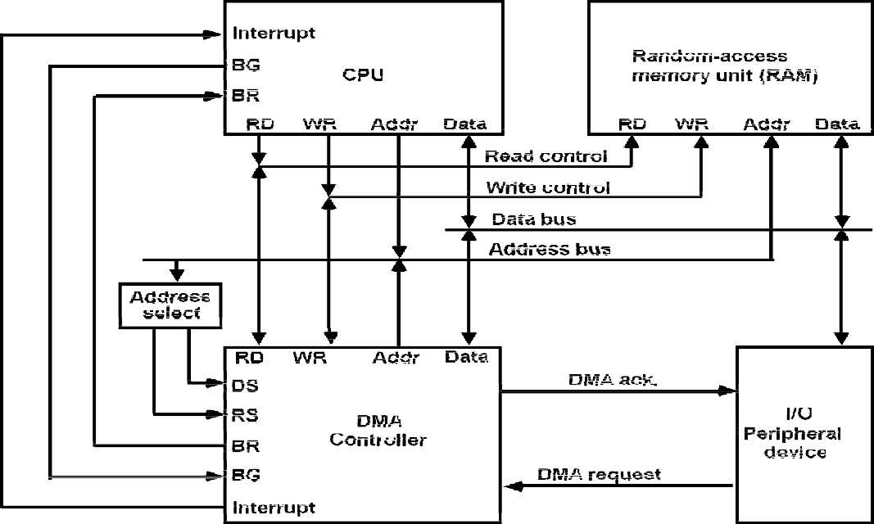

selecting particular DMA registers. The CPU initializes the DMA by sending the following information through the data bus:

1. The starting address of the memory block where data are available (for read) or where data are to be stored (for write)
2. The word count, which is the number of words in the memory block
3. Control to specify the mode of transfer such as read or write
4. A control to start the DMA transfer

* The starting address is stored in the address register. The word count is stored in the word count register, and the control information in the control register.
* Once the DMA is initialized, the CPU stops communicating with the DMA unless it receives an interrupt signal or if it wants to check how many words have been transferred.

## DMA Transfer

* The position of the DMA controller among the other components in a computer system is illustrated in following fig.
* The CPU communicates with the DMA through the address and data buses as with any interface unit. The DMA has its own address, which activates the DS and RS lines.
* The CPU initializes the DMA through the data bus. Once the DMA receives the start control command, it can start the transfer between the peripheral device and the memory.
* When the peripheral device sends a DMA request, the DMA controller activates the BR line, informing the CPU to relinquish the buses. The CPU responds with its BG line, informing the DMA that its buses are disabled.
* The DMA then puts the current value of its address register into the address bus, initiates the RD or WR signal, and sends a DMA acknowledge to the peripheral device.
* Note that the RD and WR lines in the DMA controller are bidirectional. The direction of transfer depends on the status of the BG line. When BG = 0, the RD and WR are input lines allowing the CPU to communicate with the internal DMA registers. When BG = 1, the RD and WR and output lines from the DMA controller to the random-access memory to specify the read or write operation for the data.
* When the peripheral device receives a DMA acknowledge, it puts a word in the data bus (for write) or receives a word from the data bus (for read). Thus the DMA controls the read or write operations and supplies the address for the memory.
* The peripheral unit can then communicate with memory through the data bus for direct transfer between the two units while the CPU is momentarily disabled.
* For each word that is transferred, the DMA increments its address register and decrements its word count register. If the word count does not reach zero, the DMA checks the request line coming from the peripheral.
* For a high-speed device, the line will be active as soon as the previous transfer is completed. A second transfer is then initiated, and the process continues until the entire block is transferred.
* If the peripheral speed is slower, the DMA request line may come somewhat later. In this case the DMA disables the bus request line so that the CPU can continue to execute its program. When the peripheral requests a transfer, the DMA requests the buses again.
* If the word count register reaches zero, the DMA stops any further transfer and removes its bus request. It also informs the CPU of the termination by means of an interrupt.
* When the CPU responds to the interrupt, it reads the content of the word count register. The zero value of this register indicates that all the words were transferred successfully. The CPU can read this register at any time to check the number of words already transferred.
* A DMA controller may have more than one channel. In this case, each channel has a request and acknowledges pair of control signals which are connected to separate peripheral devices. Each channel also has its own address register and word count register within the DMA controller.
* A priority among the channels may be established so that channels with high priority are serviced before channels with lower priority.
* DMA transfer is very useful in many applications.
* It is used for fast transfer of information between magnetic disks and memory.
* It is also useful for updating the display in an interactive terminal.